

**C.K.Pithawalla College of Commerce-Management-Computer Application, Surat**

VEER NARMAD SOUTH GUJARAT UNIVERSITY, SURAT

PROJECT REPORT

ON

**Internet banking management**

AS A PARTIAL REQUIREMENT FOR THE DEGREE

OF

BACHELOR OF COMPUTER APPLICATION

(B.C.A)

2024-2025

**SUBMITTED BY:**

**Jenil Dhola**

**Harsh Lakhani**

**Darshan Lakhani**

**Utsav Chheta**

**GUIDED BY:**

**Dr.Ami Desai**

**Mr. Juned Ansari**

**Acknowledgement**

The reason of completing the project work successfully is not just our efforts but efforts of many people. The people, who trusted, guided and encouraged us with every means. Guide is a person who provides you the direction towards success, so we feel great pleasure to express our gratitude to all our guides, our faculty members as well as every person who helped me directly or indirectly with our project.

We would like to thank **Dr. Marteen Patel** (In-charge Principal at C.K.Pithawalla College)and **Mr. Gaurang Joshi** (BCA-HOD at C.K.Pithawalla College)for granting us an opportunity to work on this project. Their skills and experience was a guiding path in this learning process. She made constant efforts to shape up our skills as per the industry Standards. She provided us a very homely and friendly environment which made it the best place to work. Their guidance was really priceless and will always be a guiding light in Industry.

We are also indebted to our Faculty **dr.ami desai** who provided constant encouragement, support & valuable guidance before and during our project. It was her effort who led us to this place for project work. Her guidance and suggestions were invaluable.

Thank you very much

**Jenil dhola**

**Harsh lakhani**

**Darshan lakkhani**

**Utsav chheta**

|  |  |  |  |
| --- | --- | --- | --- |
| Index | | | |
| SrNo | **Chapter** | | **Page No** |
| 1 | **Introduction** | | **1** |
|  | 1.1 | Project Profile | 2 |
|  | 1.2 | Project Introduction | 3 |
| 2 | **Environment Description** | | **4** |
|  | 2.1 | Hardware Software Requirement | 5 |
|  | 2.2 | Tools & Technology | 6 |
| 3 | **Existing System & its Limitation** | | **4** |
|  | 3.1 | Introduction | 5 |
|  | 3.2 | Limitation | 6 |
| 4 | **Proposed System** | | **13** |
|  | 4.1 | Scope | 14 |
|  | 4.2 | Aims & Objectives | 18 |
|  | 4.3 | Excepted Advantage | 19 |
| 5 | **System Model Architecture** | | **29** |
|  | 5.1 | Use Case Diagram | 30 |
|  | 5.2 | Activity Diagram | 33 |
| 6 | **System Diagram** | | **67** |
|  | 6.1 | Table Structure | 75 |
|  | 6.2 | Screen Layout | 76 |
| 7 | **System Limitations & Future Enhancements** | | **206** |
|  | 7.1 | System Limitations |  |
|  | 7.2 | Future Enhancements |  |
| 8 | **References** | | **208** |
|  | 8.1 | Bibliography | 209 |
|  | 8.2 | Webography | 210 |

**1**

Chapter

**Introduction**

|  |  |
| --- | --- |
| 1.1 | Project Profile |
| 1.2 | Project Introduction |

**1.1 Project Profile**

|  |  |  |
| --- | --- | --- |
| **Project Title** | **:** | **Internet banking management** |
| **Objective** | **:** | To provide platform for purchasing furniture |
| **Name of the Institute** | **:** | C.K.Pithawalla College of Commerce-Management - Computer Application |
| **Developed For** | **:** | DigiBankX |
| **Project Guide** | **:** | Dr.Ami Desai |
| **Front End** | **:** | PHP |
| **Back End** | **:** | MySQL |
| **Team Members** | **:** | 4 |

**1.2 Project Introduction**

* “DigiBankX” is an internet bank place which connects the buyers & sellers for selling and purchasing furniture and home decor products.
* On This website Seller & Interior Designer can Advertise their products and customers can purchase product.
* Customer give feedback on purchased product.
* Our website offers a range of products such as beds, sofas, wardrobes, Study, Decor & dining among other furniture categories.
* Our website delivers original & easy-to-assemble product directly to the customer’s door step.
* “**Wooden Street”** provides an interface to customer/User to make Inquiry regarding the Products.
* It also provides Customer to have better solution for their Inquiry.
* “**Wooden Street”** gives an opportunity to use the service support well and ultimately help the company to evaluate the product using Feedback and Product Rating given by the Customer.

**2**

Chapter

**Environment Description**

|  |  |  |  |
| --- | --- | --- | --- |
| **2.1** | **Hardware and Software Requirement** | | |
|  | | 2.1.1 | Development Tools | |
|  | | 2.1.2 | Client Side Tools | | |
| 2.1.3 | Server Side Tools | | |
| **2.2** | **Tools and Technology** | | |
|  | | 2.2.1 | Core Technology | | | |
| 2.2.2 | Extra Tools | | | |

**2.1 Hardware and Software Requirement**

* **Client Side :**

- Internet enabled devices with Web Browser

* **Server Side :**

**-** Wamp Server (2.2 Version)

- Disk Space (1 GB Minimum)

* **Development Side :**

- Processor (Intel Inside Pentinum)

- O.S (Windows 8.1)

- Memory (2 GB)

- Hard Disk (500 GB)

- Web Browser: Developed in Google Chrome (Tested in Mozilla Firefox)

**2.2 Tools and Technology**

**Technology:**

* **Core Technology** :
* **HTML:**

**-** First developed by Tim Berners-Lee in 1990, **HTML** is short for Hypertext Markup Language.

**- HTML** is used to create electronic documents (called pages) that are displayed on the World Wide Web.

**-** Each page contains a series of connections to other pages called hyperlinks.

* **MySQL:**

**- MySQL**, the most popular Open Source SQL database management system, is developed, distributed, and supported by Oracle Corporation.

**-** The **MySQL** website (http://www.**mysql**.com/) provides the latest **information about MySQL** software.

**-** A database is a structured collection of data.

* **PHP:**

**-** Hypertext Preprocessor (or simply **PHP**) is a general-purpose programming language was 32-bit x86 builds, requiring Windows 32-bit compatibility mode while using **Internet** **Information** **Services** (IIS) on a 64-bit Windows platform.

* **Extra Technology:**
* **JQuery:**

**- JQuery** is a JavaScript library designed to simplify HTML DOM tree traversal and manipulation, as well as event handling, CSS animation, and Ajax.

**- JQuery** also provides capabilities for developers to create plug-ins on top of the JavaScript library.

* **AJAX:**

**- AJAX** is a technique for creating fast and dynamic web pages.

**-** **AJAX** allows web pages to be updated asynchronously by exchanging small amounts of data with the server behind the scenes.

**-** This means that it is possible to update parts of a web page, without reloading the whole page.

* **JavaScript:**

**- JavaScript** is a dynamic computer programming language.

**-** It is lightweight and most commonly used as a part of web pages, whose implementations allow client-side script to interact with the user and make dynamic pages.

**-** It is an interpreted programming language with object-oriented capabilities.

**Tools:**

* **Documentation Tools:**
* **EDraw:**

**- Edraw** Max is a 2D business technical diagramming software which help create flowcharts, organizational charts, mind map, network diagrams, floor plans, workflow diagrams, business charts, and engineering diagrams.

**-** **Edraw** Max gives users a Visio-like, professional quality diagramming tool.

* **MS Word:**

**- Microsoft Word** or **MS**-**WORD** (often called **Word**) is a Graphical **word** processing program that users can type with.

**-** It is made by the computer company **Microsoft**. Its purpose is to allow users to type and save documents.

* **MS Power Point:**

**- PowerPoint** is a slideshow presentation program that's part of the **Microsoft** office suite of tools.

**- PowerPoint** makes it easy to create, collaborate, and present your ideas in dynamic, visually compelling ways.

* **Development Tools:**

Sublime Text 3

* **Sublime Text 3:**

**- Sublime Text 3** is an amazing piece of software.

**-** To start, it is a clean, functional, and fast code editor.

**-** Not only does it have incredible built in features (multi-edit and vim mode), but it has support for plugins, snippets, and many other things.

**3**

Chapter

|  |  |
| --- | --- |
| 3.1  3.2 | Introduction  Limitation |

**Existing System**

**3.1 Introduction**

* If you wish to buy or purchase anything you have to go to nearby mall or shop and buy the item you like.
* In Existing System shopping one doesn’t have too much of choices and has to purchase the product which is available in the shop and if suppose that product is not available then you have to look for another product.
* In Existing System shopping leads to wastage of time.

**3.2 Limitation**

* In Existing System stores have limited working hours whereas there is no such limitation in case of online stores.
* In Existing System shopping one doesn’t have too much of choices.
* If suppose product is not available then you have to look for another product.
* Leads to wastage of time.

**4**

Chapter

|  |  |
| --- | --- |
|  | 4.1 Scope  4.2 Aim and Objective  4.3 Excepted Advantage |

**Proposed System**

**4.1 Scope**

* The scope of the website “**Wooden Street”** is global.

SCOPE

VISITOR

ADMIN

USER

Super

Admin

Interior

Designer

Seller

Customer

1. **Admin:**

The key roles of Admin are:

* There are a two types of Admin in our website .

1. Super Admin
2. Sub Admin

* Super Admin do the entire task as Sub Admin dose. As well as he can also manages Sub Admin (Create, Delete, and Block) and its permission (Insert, Update, and Delete).
* Admin can do following task:
* View the information of registered Seller/Interior Designer/Customer (Activate/Deactivate) .
* Block or Unblock Seller/Interior Designer/Customer.
* Manage category, category type, category subtype of various product.
* View the feedback of website as well as feedback of various Product also can view the inquiries which provided by various customers and reply on that.
* View which customers have taken the product from which Seller/Interior Designer.
* Manage various packages for Seller and Interior Designer like Silver package, Brown package and Platinum package.
* Process on customer’s order like Not Processed, Order Processing, Shipping, and Delivered and also manage payment status.
* View the order process of seller’s product.
* View reports like Monthly Selling.
* Change their own Profile and Password.
* Manage the Newsletter for various product advertisement and also manage CMS pages like About Us, Contact Us, etc...
* Manage banner images which are shown at client side.
* Generate new offers according to new trend.

**Seller:**

The key role of Seller is:

* While Seller registering, it has to select appropriate package as per his/her requirement.
* Demand for add Category and Category type to admin.
* Process on customer’s order like Not Processed, Order Processing, Shipping, and Delivered and also manage payment status.
* View the feedback and Rating of their own Product and improve work.
* Change their own Profile and password.

1. **Interior Designer:**

The key role of Interior Designer is:

* While Interior Designer registering, it has to select appropriate package as per his/her requirement.
* Manage their recently Designed Project, location and Project image (Portfolio).
* Manage Customer request, response them and manage customer’s order.
* View the feedback and Rating of their own Project and improve work.
* Change their own Profile and Password.

1. **Customer:**

The key role of Customer is:

* Before purchasing various product customer must have to register himself/herself.
* View category and category type of product and also inquiry about product.
* View offer given by admin, seller.
* Customer can also give feedback and rating.
* Customer can view portfolio of interior designer and request for according to their requirement.
* Change their own Profile and Password.
* For purchasing product customer can add product into cart and view cart, bill and also make payment.
* Customer can Track their Order.

1. **Visitor:**

The key role of Visitor is:

* Visitor can view client pages, product and also make inquiry.
* View the status of product on the basis of ratings & feedback which given by customer and also view portfolio of interior designer.
* Visitors have to register himself/herself to purchase the product.

**4.2 Aims and Objectives**

* Our aim is to provide user friendly platform for different Seller and Interior designer to enhance their business in e-commerce market.
* Through this website Seller and Interior designer can improve their products quality using feedback.
* Also reduce paperwork and increase efficiency.
* Customer can get best product and services on their door step.

Sub

Admin

CUSTOMER

VISITOR

**4.3 Excepted Advantages**

* The Website allows admin to modify client side pages, manage visitors & satisfy the customers.
* The Website allows visitors to view client pages and get required information.
* The customers get good services and response from the website for their requirement.
* Websiteprovides an interface to customer to make Inquiry regarding the Product.
* It also provides Customer to have better solution for their Inquiry within no times.
* Website help the Seller/Interior designer to evaluate the product using Feedback and Product Rating given by the Customer.
* Online shopping as the name tells it is done over internet, so you don’t have to stand in line or go anywhere from your home to purchase the products you like.
* In Proposed System shopping offers convenience of shopping 24 hours a day, seven days a week.
* In online shopping variety of different products are available at one website.

**5**

Chapter

**System Model Architecture**

|  |  |
| --- | --- |
| 5.1 | Use Case Diagram |
| 5.2 | Activity Diagram |

**5.1 Use Case Diagram**

* **Super Admin’s Use Case Diagram:**



* **Sub Admin’s Use Case Diagram:**



* **Seller’s Use Case Diagram:**



* **Interior Designer’s Use Case Diagram:**



* **Customer’s Use Case Diagram:**



* **Visitor’s Use Case Diagram:**



**5.2 Activity Diagram**

* **Activity Diagram for Admin:**



**Admin**



**Login**



**Check EmailID & Password**



**Logged On**



**Forgot Password**



**Validate Data**



**Manage Staff**



**Manage Clients**



**Manage Account Type**



**Manage Loans**



**Manage System Settings**



**Change Paawrod & Profile**



**View Feedback**



**Transaction History**



**Financial Reports**



**Deposit Interest**



**Balance Enquiries**



**Logout**



**1**

**5**

**4**

**3**

**2**

**6**

**7**

**8**

**9**

**10**

**Y**

**N**

**N**

**Y**

* **Activity Diagram for Admin – Staff Management:**

**1**



**Manage Staff**



**Add New**

**Staff**



**View Staff**



**Enable/Disable**

**Staff**



**Edit Staff**



**Error**



**Error**



**Error**

**Valid**

**Data?**

**Valid**

**Data?**

**Valid**

**Data?**



**Staff Added**



**Staff Updated**



**Staff**

**Enabled/Disabled**

**End**

**No**

**N**

**N**

**Yes**

**Yes**

**Yes**

* **Activity Diagram for Admin – Client Management:**

**1**



**Manage Clients**



**View Clients**



**Enable/Disable**

**Staff**



**Edit Staff**



**Error**



**Error**

**Valid**

**Data?**

**Valid**

**Data?**



**Staff Updated**



**Staff**

**Enabled/Disabled**

**End**

**N**

**N**

**Yes**

**Yes**

* **Activity Diagram for Admin – Account Type Management:**

**1**



**Manage Accounts**



**Add New**

**Staff**



**View Accounts**



**Enable/Disable**

**Staff**



**Edit Staff**



**Error**



**Error**



**Error**

**Valid**

**Data?**

**Valid**

**Data?**

**Valid**

**Data?**



**Staff Added**



**Staff Updated**



**Staff**

**Enabled/Disabled**

**End**

**No**

**N**

**N**

**Yes**

**Yes**

**Yes**

* **Activity Diagram for**
* **Activity Diagram for Sub Admin – Category Management:**



* **Activity Diagram for Sub Admin – Location Management:**



* **Activity Diagram for Sub Admin – CMS Page Management:**



* **Activity Diagram for Sub Admin – Feedback Management:**



* **Activity Diagram for Sub Admin – Package Management:**



* **Activity Diagram for Sub Admin – Inquiry Management:**



* **Activity Diagram for Sub Admin – Banner Management:**



* **Activity Diagram for Sub Admin – Order Management:**



* **Activity Diagram for Sub Admin – Payment Management:**



* **Activity Diagram for Sub Admin – Offer Management:**



* **Activity Diagram for Sub Admin – Newsletter Management:**



* **Activity Diagram for Seller:**



* **Activity Diagram for Seller – Product Management:**



* **Activity Diagram for Seller – Demand New Category Management:** 
* **Activity Diagram for Seller – Feedback Management:**



* **Activity Diagram for Seller – Inquiry Management:**



* **Activity Diagram for Seller – Order Management:**
* **Activity Diagram for Seller – Payment Management:**



* **Activity Diagram for Seller – Newsletter Management:**



* **Activity Diagram for Interior Designer:**



* **Activity Diagram for Interior Designer – Project Management:**



* **Activity Diagram for Interior Designer – Customer Request**

**Management:**



* **Activity Diagram for Interior Designer – Feedback Management:**



* **Activity Diagram for Interior Designer – Inquiry Management:**



* **Activity Diagram for Customer:**



* **Activity Diagram for Visitor:**



**6**

Chapter

**System Diagram**

|  |  |
| --- | --- |
| 6.1 | Table Structure |
| 6.2 | Screen Layout |

**6.1 Table Structure**

**Table Name:** client_feedback  
**Use:** It is used to store the information of client_feedback.

|  |  |  |  |
| --- | --- | --- | --- |
| Field | Type | Constraints | Description |
| ID | int(10) | Primary Key (AutoIncrement) | Unique field. |
| client_id | Int(10) | foreign key | Unique field. |
| subject | varchar(255) | Not Null | Specify subject |
| feedback_message | text | Not Null | Specify feedback |
| Submission_date | Timestamp | Current Timestamp | Specify Contact Number. |

**Table Name : ib_acc_types**

**Use :** It is used to store the information of a/c types.

|  |  |  |  |
| --- | --- | --- | --- |
| Field | Type | Constraints | Description |
| acctype_id | int(10) | Primary Key (AutoIncrement) | Unique field. |
| Name | varchar(200) | Not Null | Specify Name. |
| discription | Longtext | Not null | Specify description |
| Rate | Varchar(200) | Not null | Specify rate |
| code | Varchar(200) | Not null | Specify code |
| Is_active | Tinyint(1) | Not null | Specify active |
| Min_balance | Decimal(10,2) | Not null | Specify minimum balance |

**Table Name :** ib_admin

**Use :** It is used to store the information of .

|  |  |  |  |
| --- | --- | --- | --- |
| Field | Type | Constraints | Description |
| Admin_id | int(11) | Primary Key (AutoIncrement) | Unique field. |
| Name | varchar(200) | Not Null | Specify Name. |
| email | varchar(200) | Not null | Specify email |
| Number | varchar(200) | Not null | Specify number |
| password | varchar(200) | Not null | Specify password |
| profile_pic | varchar(200) | Not null | Specify profile picture |
| Is_active | Tinyint(1) | Not null | Specify active |
| otp | Varchar(6) | allows null | Specify otp |
| Otp_expiry | Date_time | Allows null | Specify otp expiry |

**Table Name : ib_bankaccounts**

**Use :** It is used to store the information of .

|  |  |  |  |
| --- | --- | --- | --- |
| Field | Type | Constraints | Description |
| account_id | int(11) | Primary Key (AutoIncrement) | Unique field. |
| Acc_Name | varchar(200) | Not Null | Specify a/c Name. |
| account_number | varchar(200) | Not null | Specify a/c number |
| Acc_type | varchar(200) | Not null | Specify acc type |
| Acc_rate | varchar(200) | Not null | Specify acc rate |
| Acc_status | varchar(200) | Not null | Specify acc status |
| Acc_amount | varchar(200) | Not null | Specify a/c amount |
| client_id | int(10) | allows null | Specify client id |
| Created-at | timestamp | not null | Specify created-at |
| Is_active | Tinyint(1) | Not null | Specify active |

**Table Name : ib_clients**

**Use :** It is used to store the information of .

|  |  |  |  |
| --- | --- | --- | --- |
| Field | Type | Constraints | Description |
| client_id | int(11) | Primary Key (AutoIncrement) | Unique field. |
| Name | varchar(200) | Not Null | Specify Name. |
| phone | varchar(200) | Not null | Specify phone |
| Adress | varchar(200) | Not null | Specify adress |
| Email | varchar(200) | Not null | Specify email |
| Adhar_number | varchar(200) | Not null | Specify adhar_number |
| Pan_number | varchar(200) | Not null | Specify pan_number |
| password | varchar(200) | Not null | Specify password |
| Profile_pic | Varchar(200) | not null | Specify profile picture |
| client_number | varchar(200) | Not null | Specify client number |
| Is_active | Tinyint(1) | Not null | Specify active |
| otp | Varchar(6) | allows null | Specify otp |
| Otp_expiry | Datetime | Allows null | Specify otp expiry |

**Table Name : ib_nominees**

**Use :** It is used to store the information of nominees .

|  |  |  |  |
| --- | --- | --- | --- |
| Field | Type | Constraints | Description |
| id | int(11) | Primary Key (AutoIncrement) | Unique field. |
| client_id | int(11) | Not null | Specify client id. |
| Nominee_Name | varchar(200) | Not Null | Specify nominee Name. |
| Relation | varchar(200) | Not null | Specify |
| Nominee_Email | varchar(200) | Not null | Specify nominee email |
| Nominee_phone | varchar(200) | Not null | Specify Nominee_phone |
| Nominee_Adress | varchar(200) | Not null | Specify Nominee_adress |
| Is_active | Tinyint(1) | Not null | Specify active |
| Adhar_number | varchar(12) | Not null | Specify adhar_number |
| Pan_number | varchar(10) | Not null | Specify pan_number |

**Table Name :ib_staff**

**Use :** It is used to store the information of staff .

|  |  |  |  |
| --- | --- | --- | --- |
| Field | Type | Constraints | Description |
| staff_id | int(11) | Primary Key (AutoIncrement) | Unique field. |
| Name | varchar(200) | Not Null | Specify Name. |
| staff_number | varchar(200) | Not null | Specify staff_number |
| phone | varchar(200) | Not null | Specify phone |
| Email | varchar(200) | Not null | Specify email |
| password | varchar(200) | Not null | Specify password |
| Sex | varchar(200) | Not null | Specify sex |
| Profile_pic | Varchar(200) | not null | Specify profile picture |
| otp | Varchar(6) | allows null | Specify otp |
| Otp_expiry | Datetime | Allows null | Specify otp expiry |
| Adhar_number | varchar(12) | Not null | Specify adhar_number |
| Pan | varchar(10) | Not null | Specify pan_number |

**Table Name :ib_systemsetting**

**Use :** It is used to store the information of **systemsettin**

|  |  |  |  |  |
| --- | --- | --- | --- | --- |
| Field | Type | | Constraints | Description |
| Id | int(11) | | Primary Key (AutoIncrement) | Unique field. |
| Sys_Name | longtext | | Not Null | Specify name. |
| Sys_lageline | longtext | | Not null | Specify tageline |
| Sys_logo | Varchar(200) | | Not null | Specify logo |
| Is_active | | Tinyint(1) | Not null | Specify active |

**Table Name :ib_transaction**

**Use :** It is used to store the information of **transaction** .

|  |  |  |  |  |  |  |
| --- | --- | --- | --- | --- | --- | --- |
| Field | | Type | | Constraints | | Description |
| tr_id | | int(11) | | Primary Key (AutoIncrement) | | Unique field. |
| code | Varchar(200) | | Not null | | Specify code | |
| account_id | | int(11) | | foreign keyclienbt | | Specify account id |
| Tr_type | | Varchar(200) | | Not null | | Specify type |
| Tr_status | | Varchar(200) | | Not null | | Specify status |
| client_id | | Int(10) | | foreign key | | Unique field. |
| transaction_amt | | Varchar(200) | | Not null | | Specify **transaction amt** |
| receiving_acc_no | | Varchar(200) | | Not null | | Specify **receiving acc no** |
| Created-at | | timestamp | | not null | | Specify created-at |
| Is_active | | Tinyint(1) | | Not null | | Specify active |

**Table Name :ib_loan_applicant**

**Use :** It is used to store the information of **applicant**.

|  |  |  |  |  |  |  |
| --- | --- | --- | --- | --- | --- | --- |
| Field | | Type | | Constraints | | Description |
| id | | int(10) | | Primary Key (AutoIncrement) | | Unique field. |
| applicant_name | Varchar(255) | | Not null | | Specify code | |
| loan_amount | | decimal(10,2) | | foreign keyclient | | Specify account id |
| Application_date | | datetime | | Not null | | Specify type |
| status | | enum | | Not null | | Specify status |
| Reviewed_by | | Int(11) | | foreign key | | Unique field. |
| admin_review_id | | Int(11) | | Not null | | Specify **transaction amt** |
| Review_date | | datetime | | Not null | | Specify **receiving acc no** |
| Staff_remark | | text | | not null | | Specify created-at |
| admin_remark | | text | | Not null | | Specify active |
| Client_id | | Int(10) | | None | | Specify cid |
| Loan_type_id | | Int(11) | | Null | | Specify loan_type_id |
| is_approved_by_staff | | Tinyint(1) | | None | | Specify staff |
| income_salary | | Decimal(10,2) | | None | | Specify income |
| loan_duration_years | | Int(11) | | None | | Specify loan |
| |  |  | | --- | --- | | **loan_duration_months** |  | | | Int(11) | | none | | Specify duration |

**Table Name : loan_payments**

**Use :** It is used to store the information of **loan_payments** .

|  |  |  |  |  |  |  |
| --- | --- | --- | --- | --- | --- | --- |
| Field | | Type | | Constraints | | Description |
| id | | int(10) | | Primary Key (AutoIncrement) | | Unique field. |
| Client_id | int(10) | | Not null | | Specify client id | |
| loan_id | | int(10) | | foreign keyclient | | Specify loan id |
| emi_date | | date | | Not null | | Specify emi date |
| amount | | Decimal(10.2 | | Not null | | Specify amount |
| status | | enum | | foreign key | | Specify status. |
| Created_at | | timestamp | | Not null | | Specify **created at** |

**Table Name : loan_types**

**Use :** It is used to store the information of loan type .

|  |  |  |  |  |  |  |
| --- | --- | --- | --- | --- | --- | --- |
| Field | | Type | | Constraints | | Description |
| id | | int(10) | | Primary Key (AutoIncrement) | | Unique field. |
| type_name | Varchar(100) | | Not null | | Specify type_name | |
| description | | text | | foreign keyclient | | Specify description |
| interest_rate | | Decimal(5,2) | | Not null | | Specify rate |
| Max_amount | | Decimal(15,2) | | Not null | | Specify amount |
| Created_at | | Timestamp | | foreign key | | Unique field. |
| Is_active | | tinyInt(11) | | Not null | | Specify active |

**Table Name : loan_types**

**Use :** It is used to store the information of .

|  |  |  |  |  |  |  |
| --- | --- | --- | --- | --- | --- | --- |
| Field | | Type | | Constraints | | Description |
| id | | int(10) | | Primary Key (AutoIncrement) | | Unique field. |
| Admin_id | int(10) | | Not null | | Specify admin_id | |
| token | | Varchar(64) | | foreign keyclient | | Specify token |
| expiry | | datetime | | Not null | | Specify expiry |

**6.2 Screen Layout**

* **Admin Side:**

**Login:-**

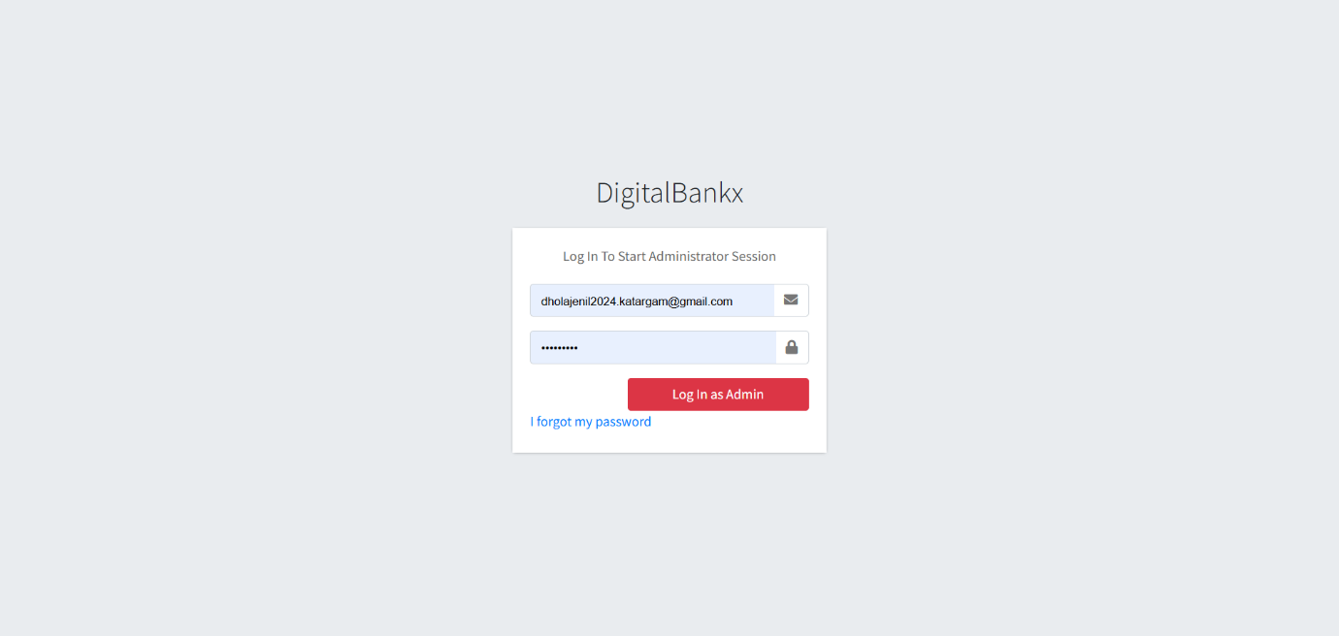

* In this page admin can login in to own website for authentication check.
* In any situation admin forgot the password they can get password on registered mail it will display on next page.

* **Forget Password:-**

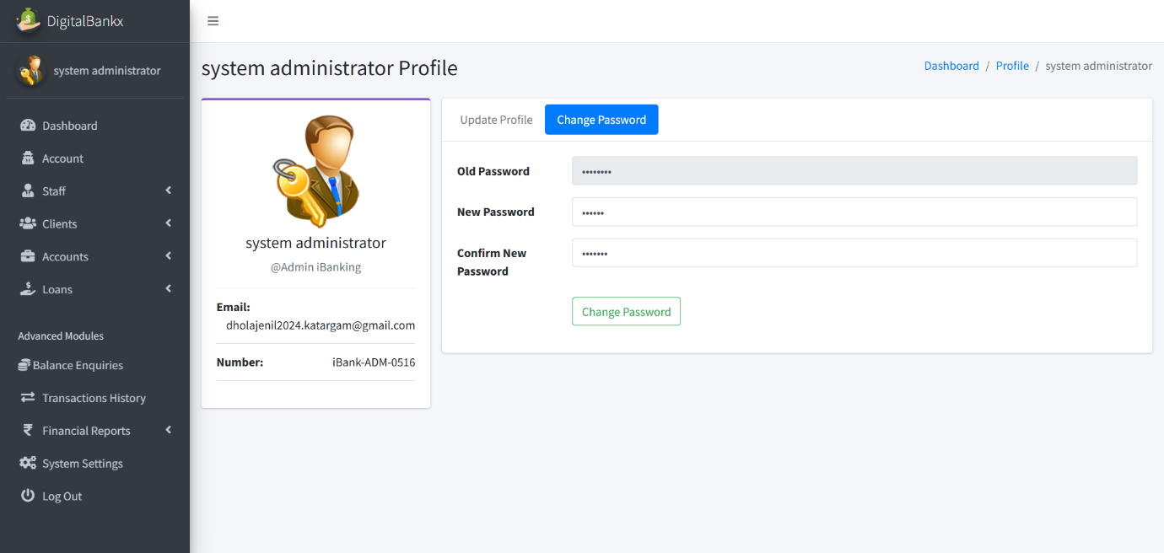

* Admin get their Forgot password through email and if they want to change it they can change password after login

**Dashboard:-**

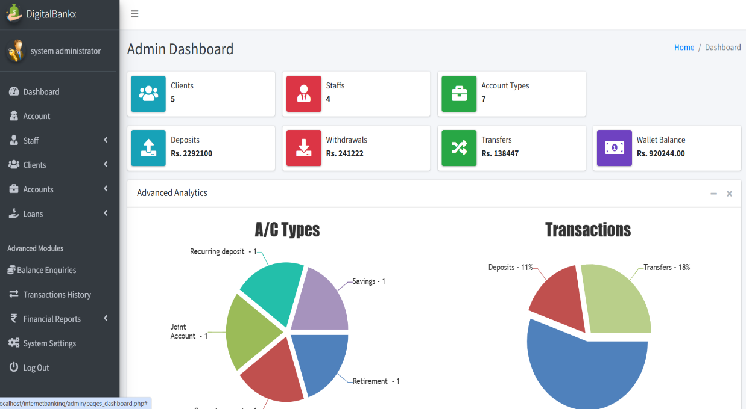

* In this Page admin can see the Dash Board, how many clients,staff, a/c types,deposits, withdrawlas ,transfer ,wallet balance

**Admin update profile:**

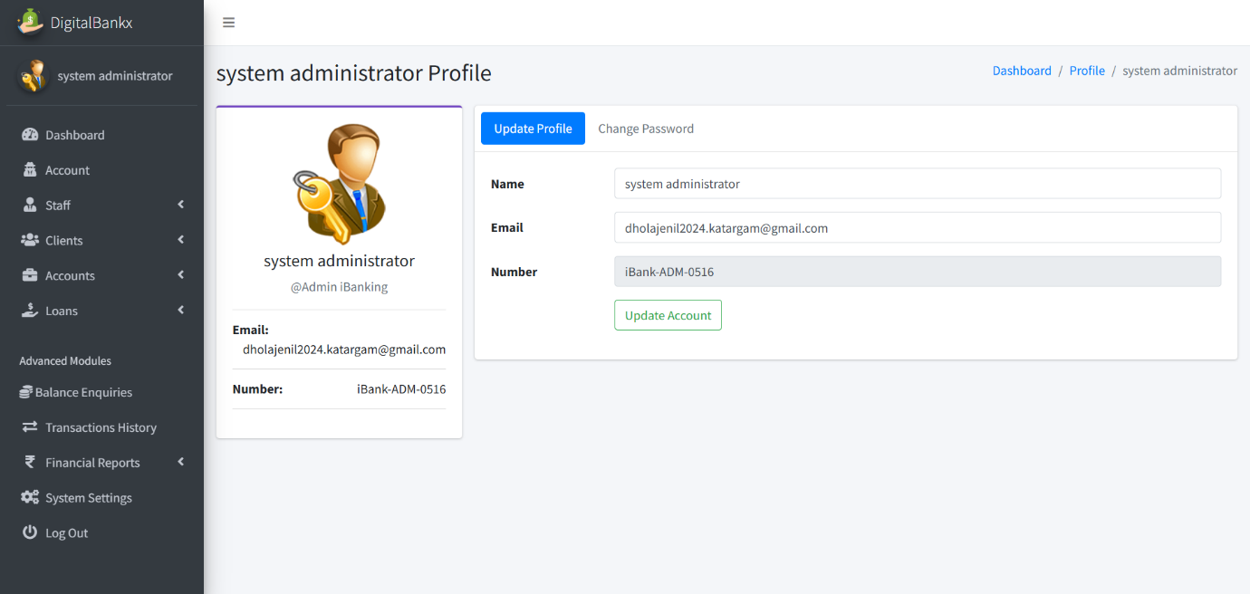

iin

* in this admin can update their profile. For update they have to enter name and email .

**Admin change password :**



* In this page Admin change the password. they have to enter old password and then they have to enter new password and confirm password.

**Change password OTP**

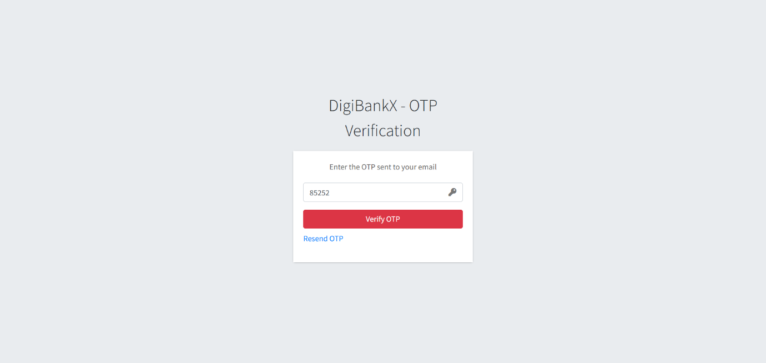

* If you forgot the password we have fasality of change password with OTP verification.

**Create staff :**

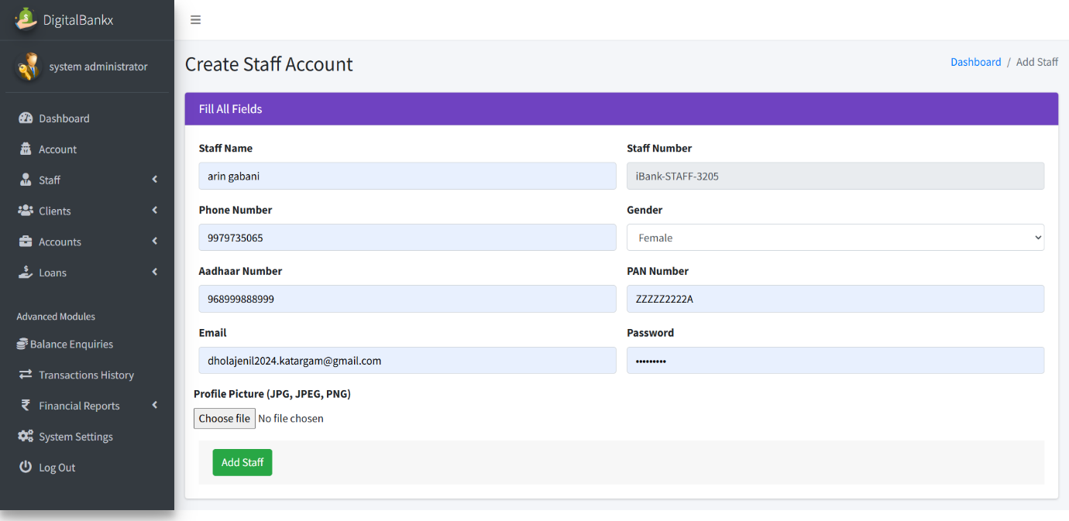

* In this page Admin can create a staff . it can ad staff after enter staff name,mo. Number ,gender , aadhar number , pann number etc.

**staff page:**

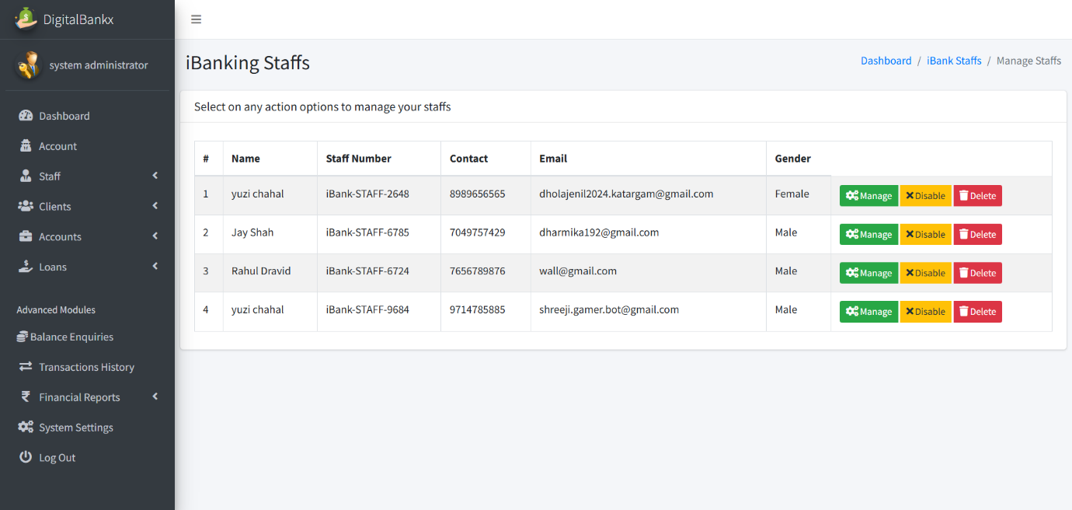

* In this page admin can see the list of staff and also it can disable and delete the staff.
* Admin can active or deactive them.

**manage staff :**

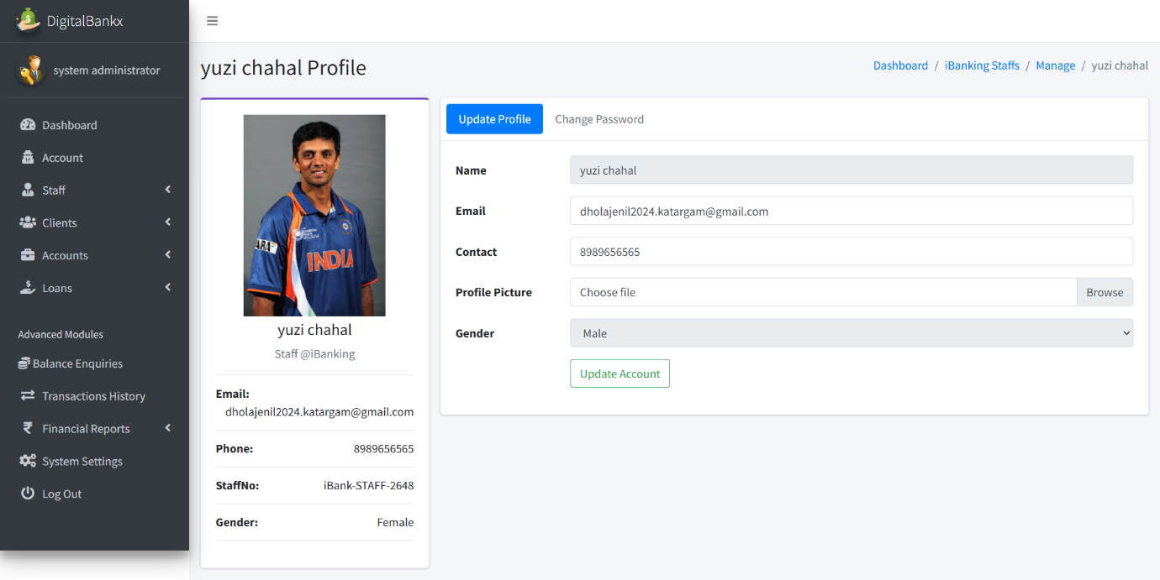

* In this page admin can change staff profile . they can change password also.

**Client page :**

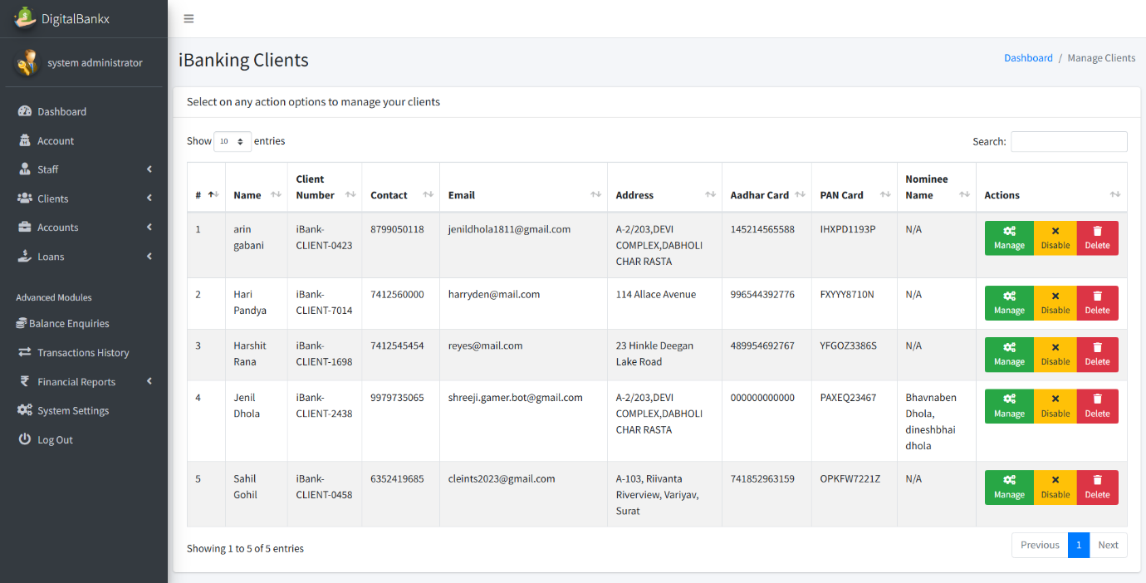

* In this Page admin can see list of clients. Admin can mange , disable and delete the staff.
* Admin can disable and enable the client.

**Manage clients :**

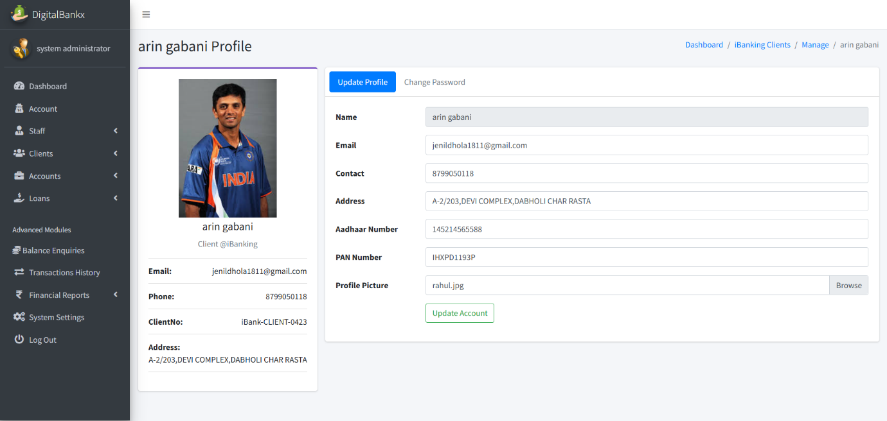

* In this page admin can update the profile of clients.
* Admin can change the pass word of clients.

**Create account categories :**

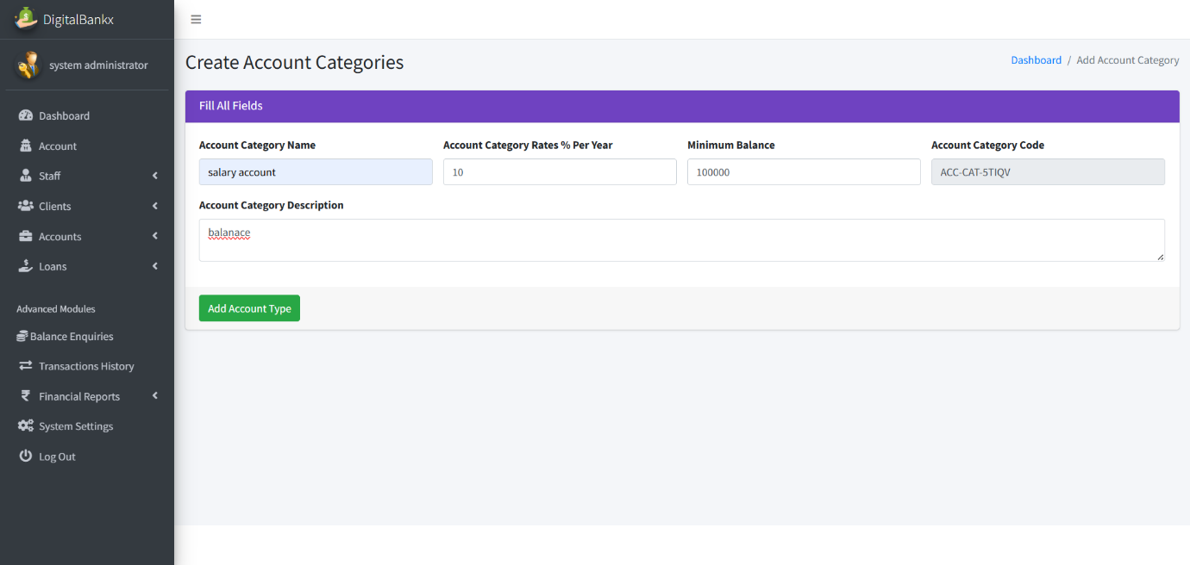

* In this page admin create the account categories by add name , rates , min balance of it .

**Manage a/c type:**

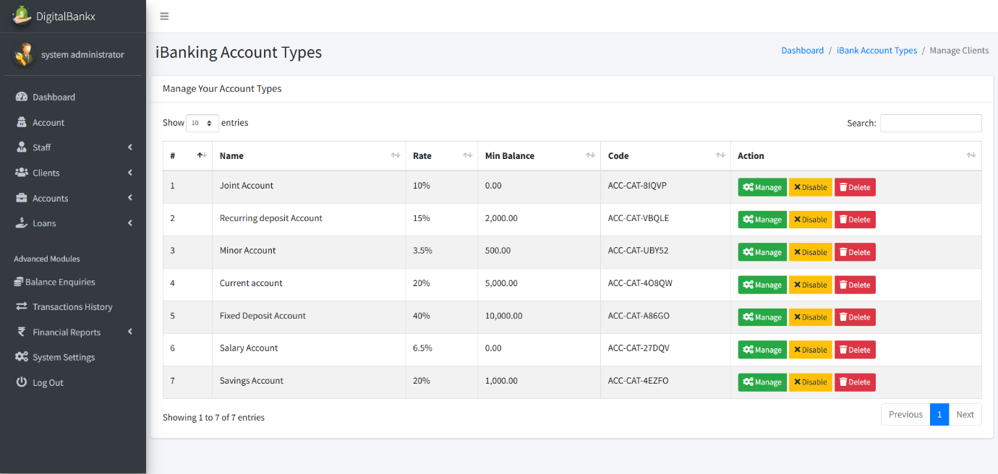

* In this Page admin can see list of account types .
* Admin can manage disable and delete the types.

**Update category name :**

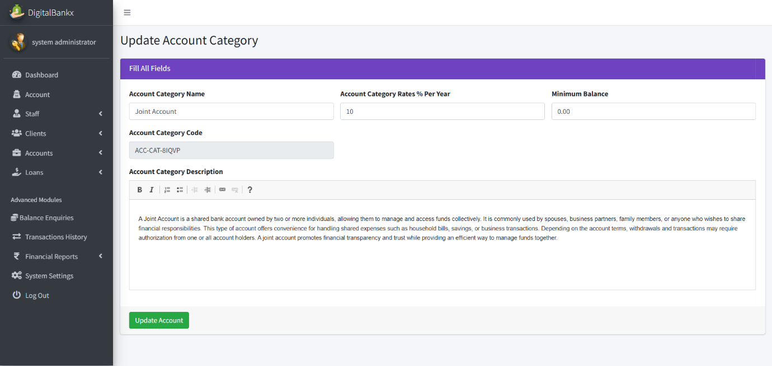

In this page admin can update account category.

**Manage a/c :**

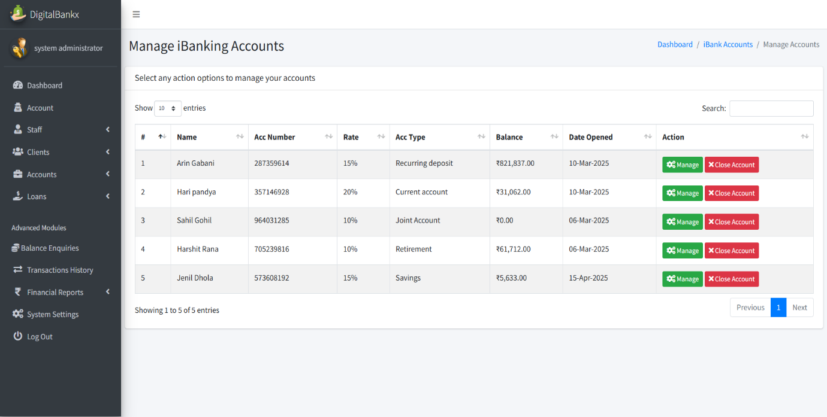

* In this page admin can see list of a accounts.
* Admin can manage and close account

**update a/c type :**

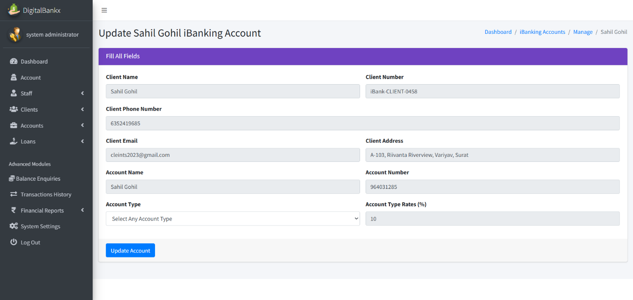

* In this page admin can update the clients account
* Admin can convert the account type .

**Loan application:**

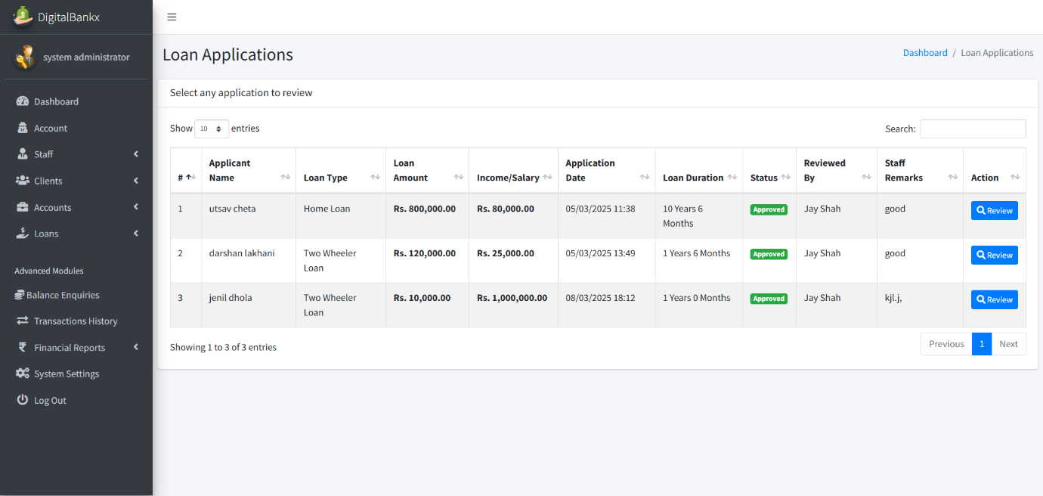

* In this page admin can see list of loan application and see its status also.

**Review loan application:**

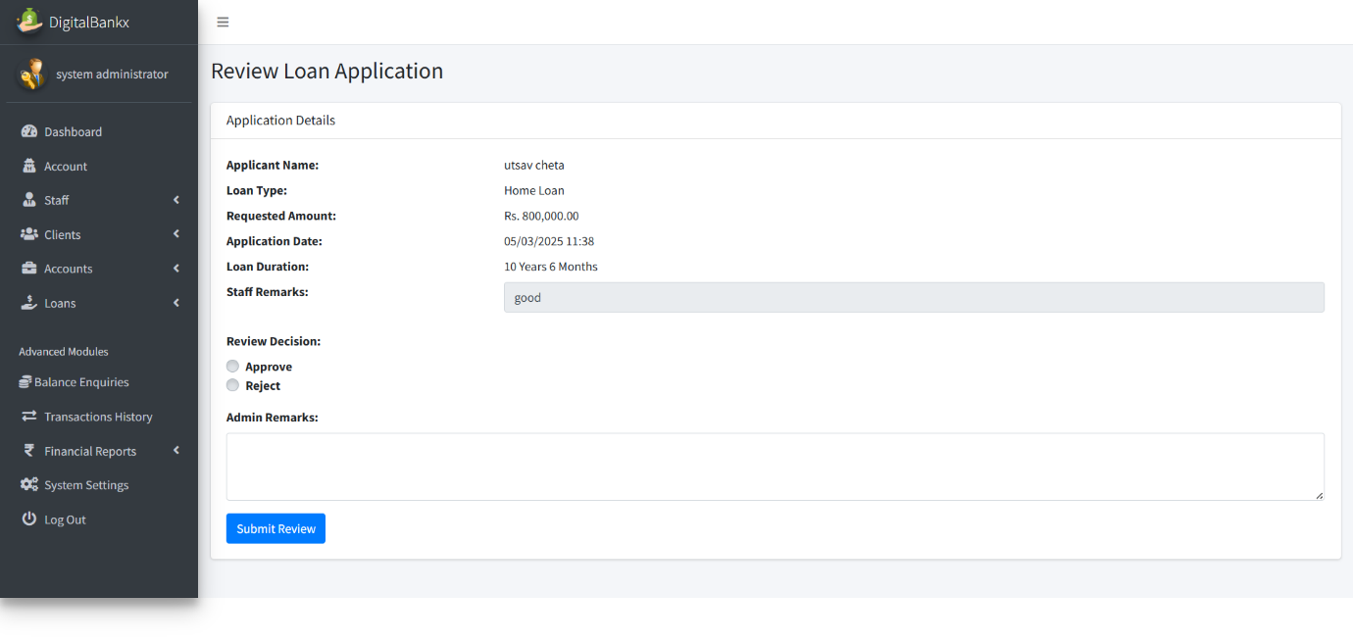

* In this page admin can review loan application.
* Admin also approve or reject the loan.

**Add loan type :**

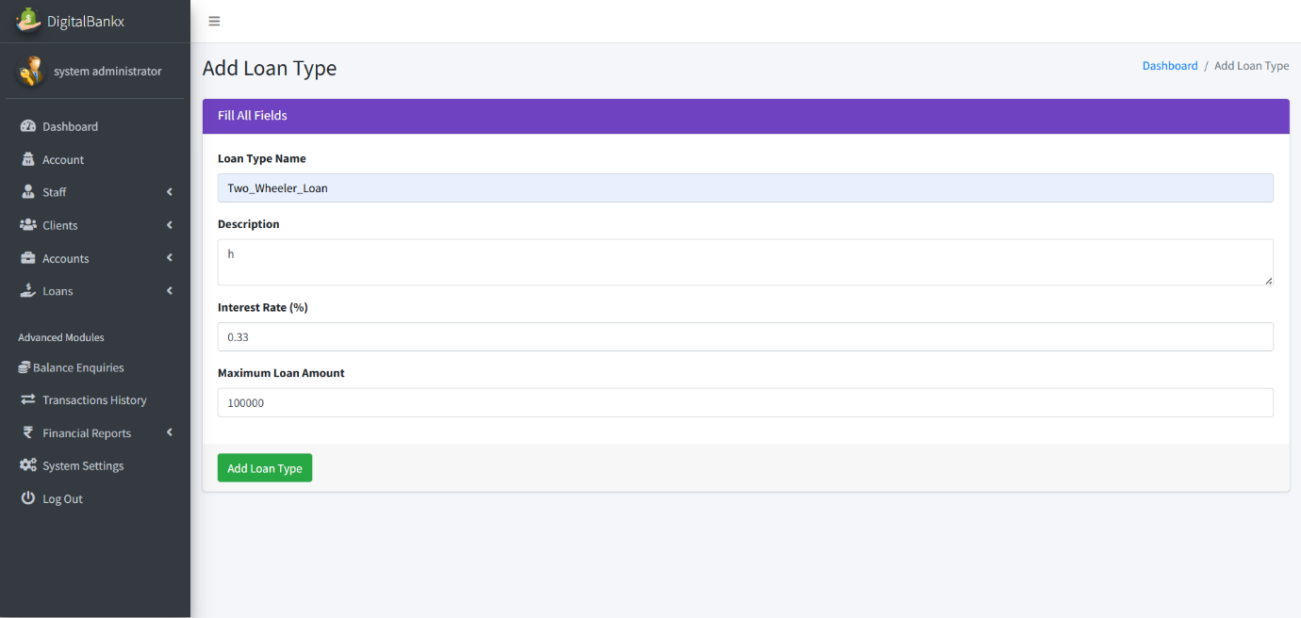

In this page admin can add loan type by add loan type name,description and max amount .

**Edit loan type:**

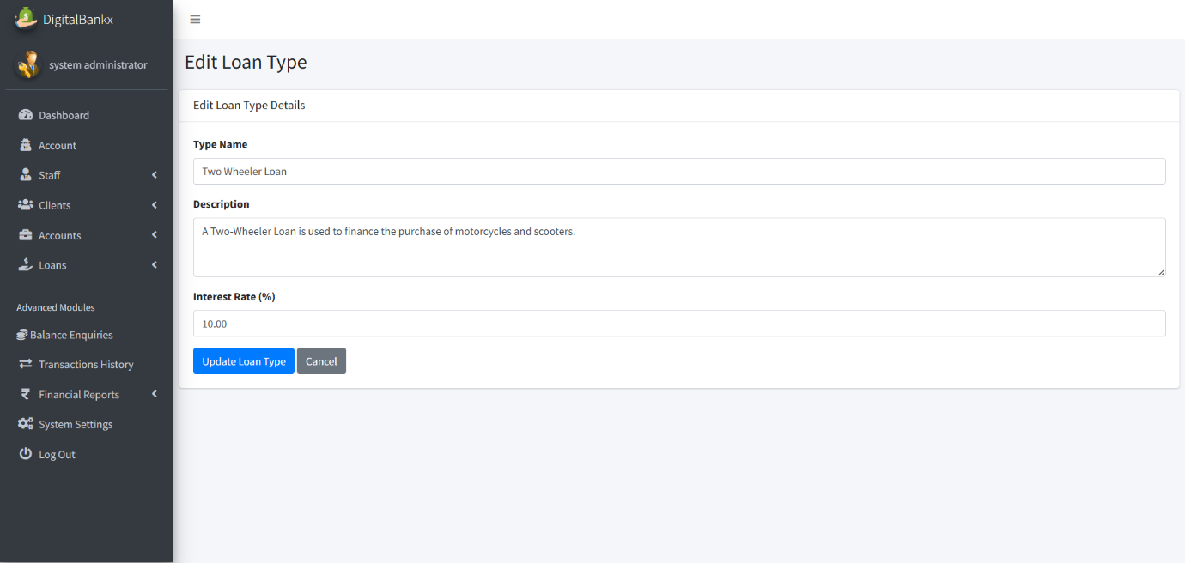

* In this page admin can edit the loan type .

**Balance enquiries:**

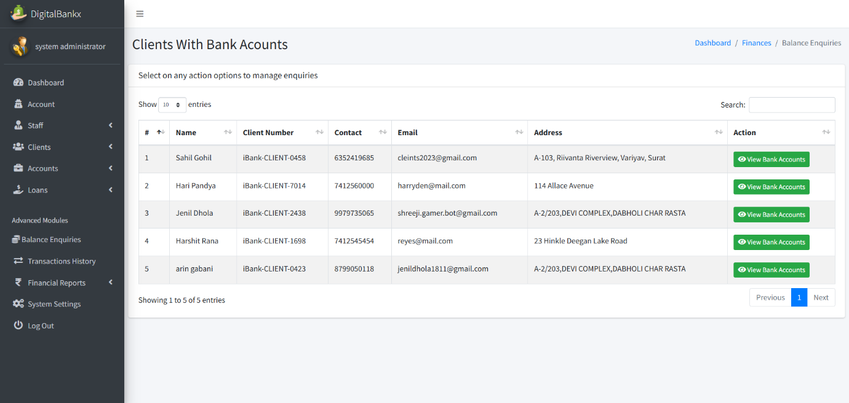

* In this page admin can see list of clients account .

**Check balance:**

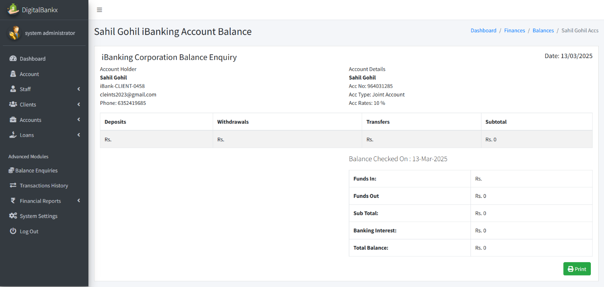

* In this page admin can see account balance .
* Admin can also see the total funds in and out.

**Transaction history :**

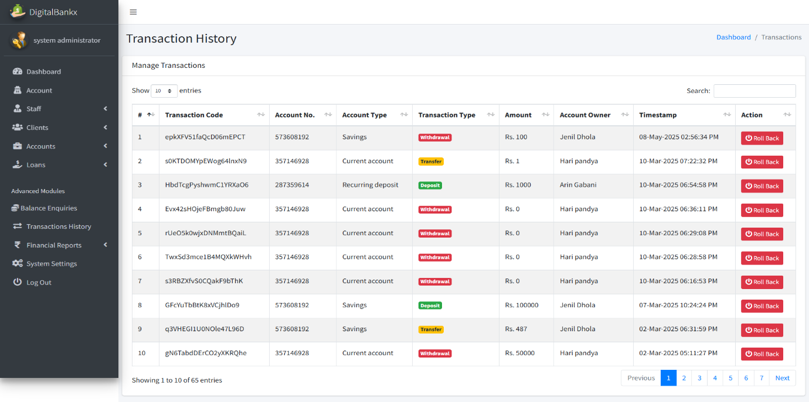

* In this page admin can see the whole transaction history .

**Deposite report:**

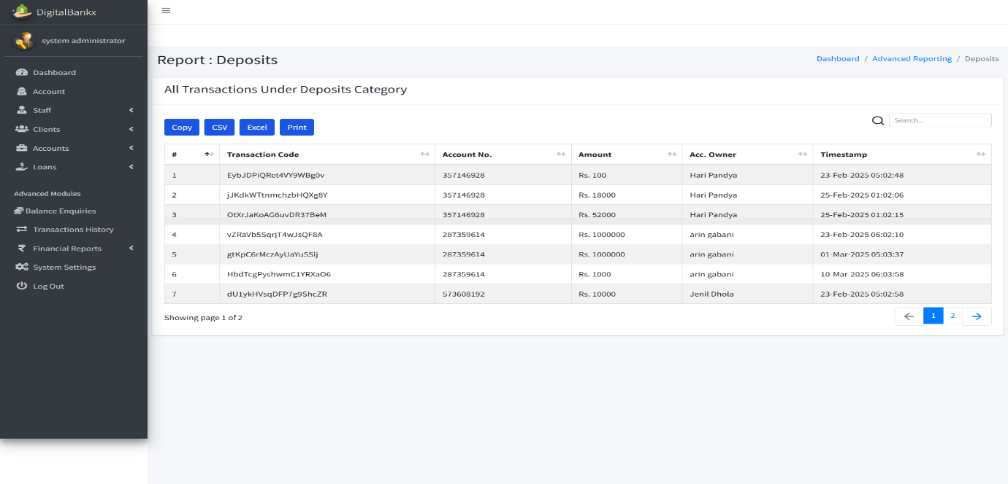

* In this page admin can see the whole history of deposite data.

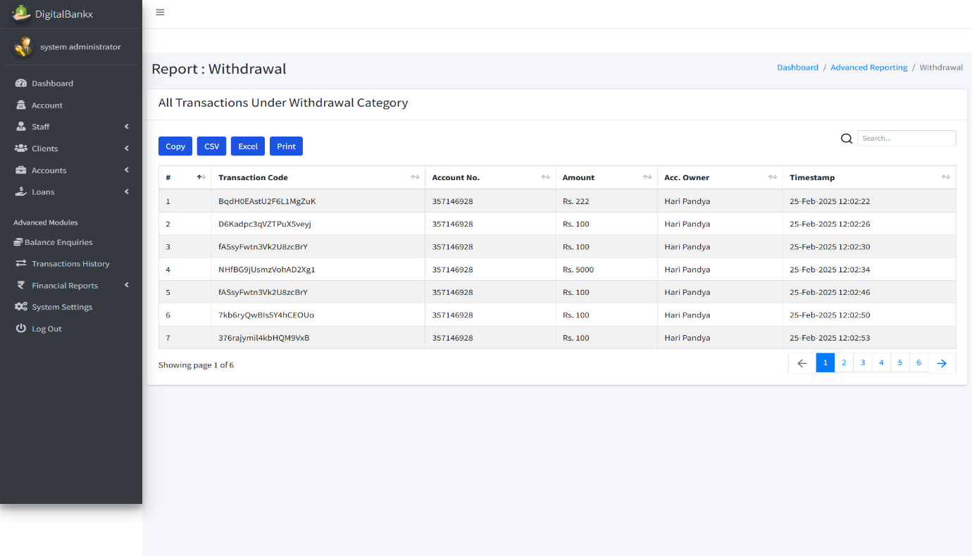**Withdrawal report:**

* In this page admin can see whole withdrawal history .

**Transfer report:**

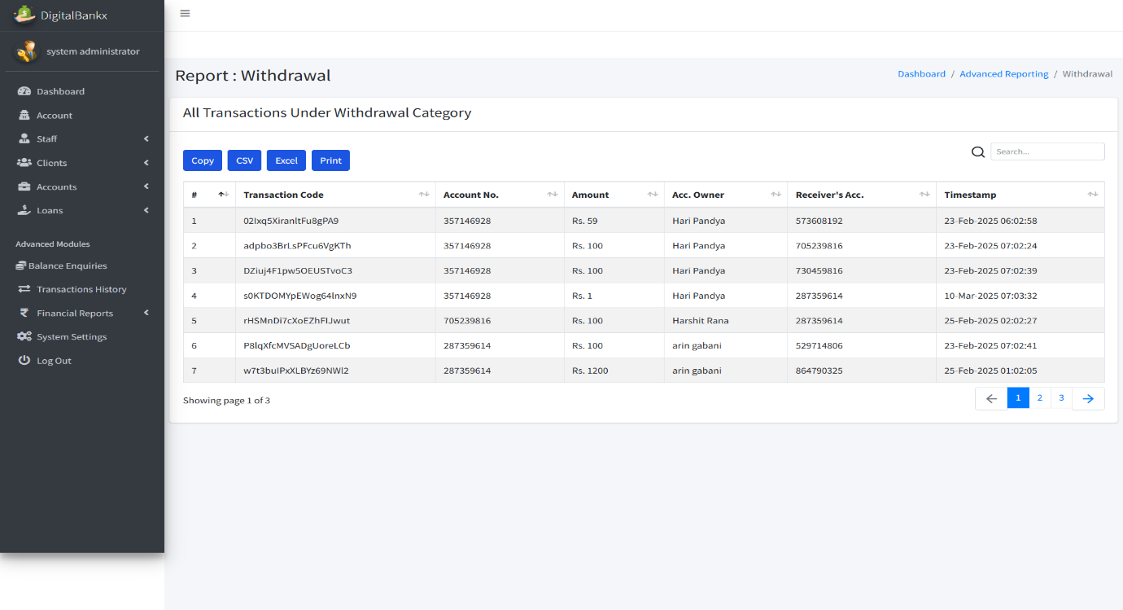

* In this page admin can see whole transfer history .

**System setting :**

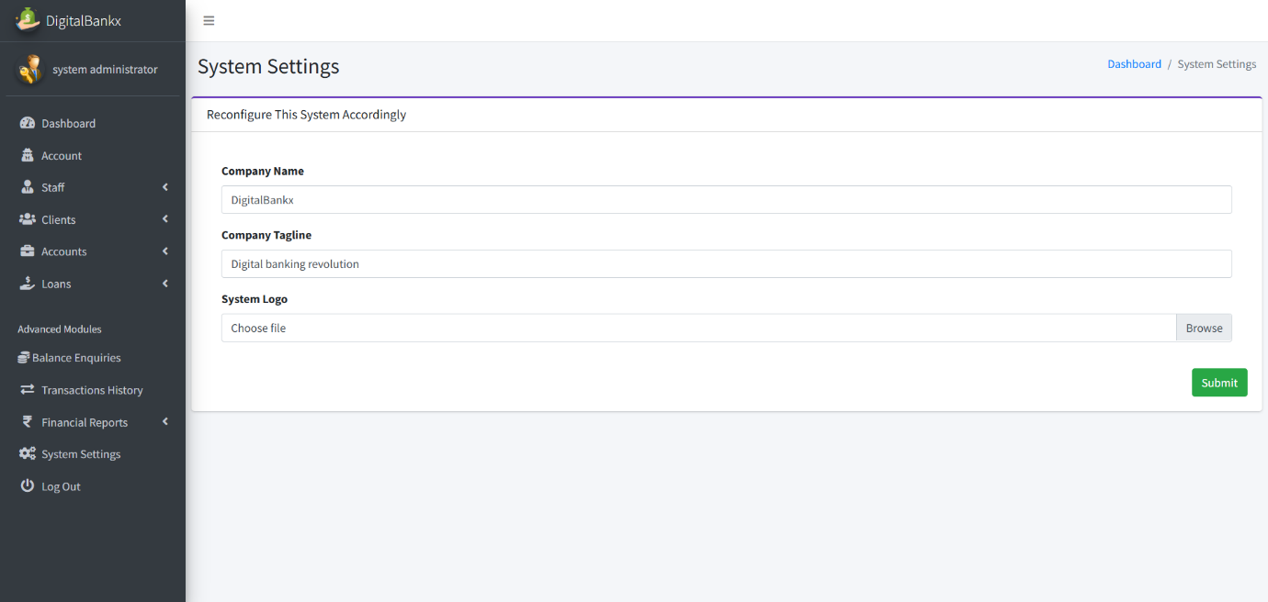

* In this page admin can update the system setting .
* Like company name , company tagline and system logo etc.
* **Staff Side:**

**Staff login:**

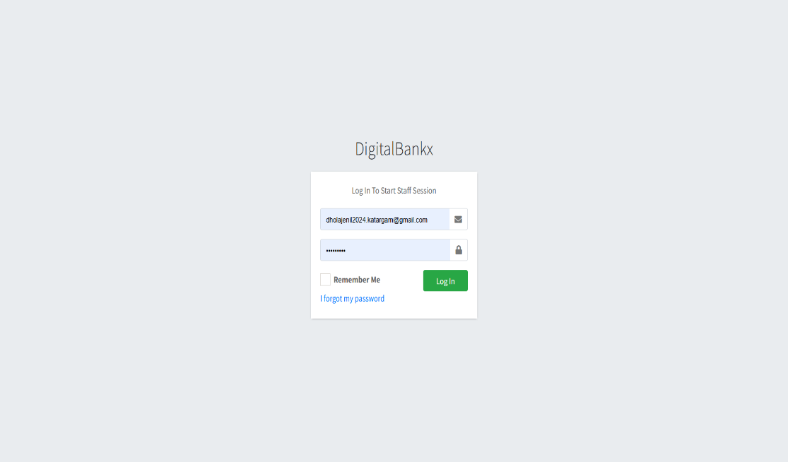

* In this page login to staff session and access the internal system.
* It allows staff members to securely log in using their job functions.

**Staff dashboard:**

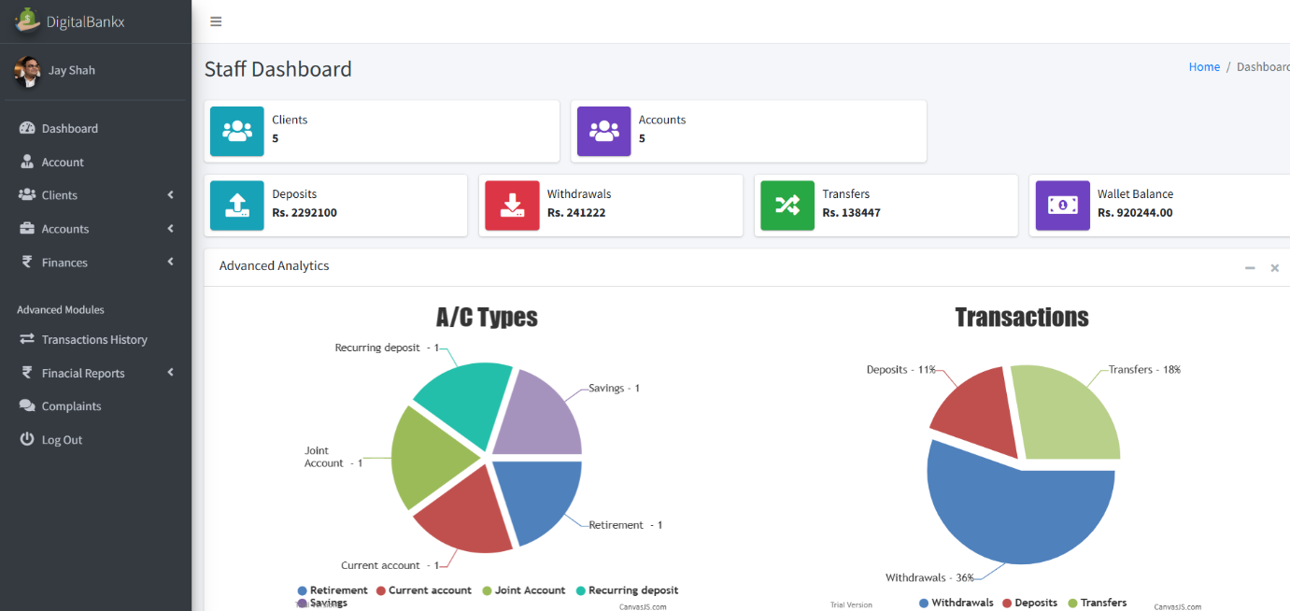

* **in this page access transaction history, complaints, financial reports, and other modules.**
* **View reports and charts on account types and transaction trends.**

**Staff account :**

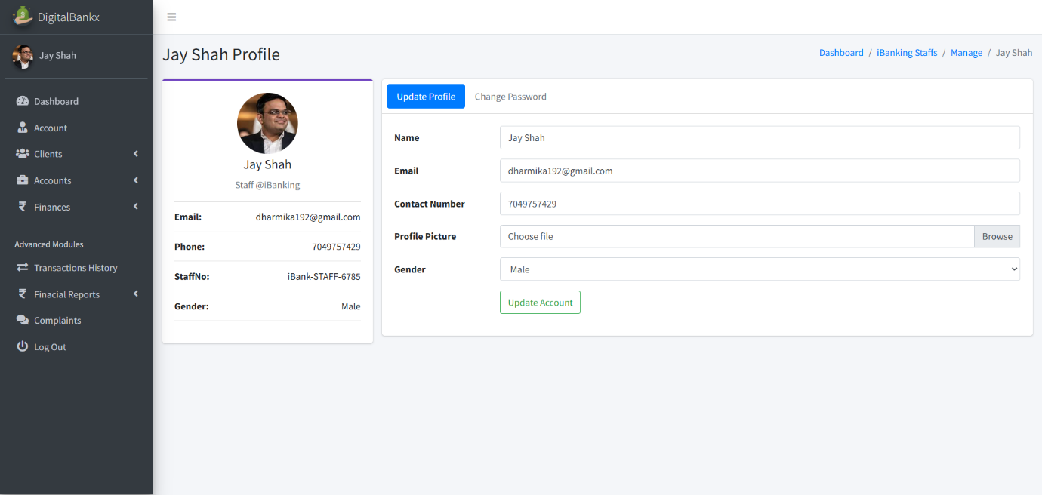

* **In this page staff can update their name, email, contact number and profile picture.**
* **Staff account section is used to mange individual employee profiles within the banking system.**

**IB Clients:**

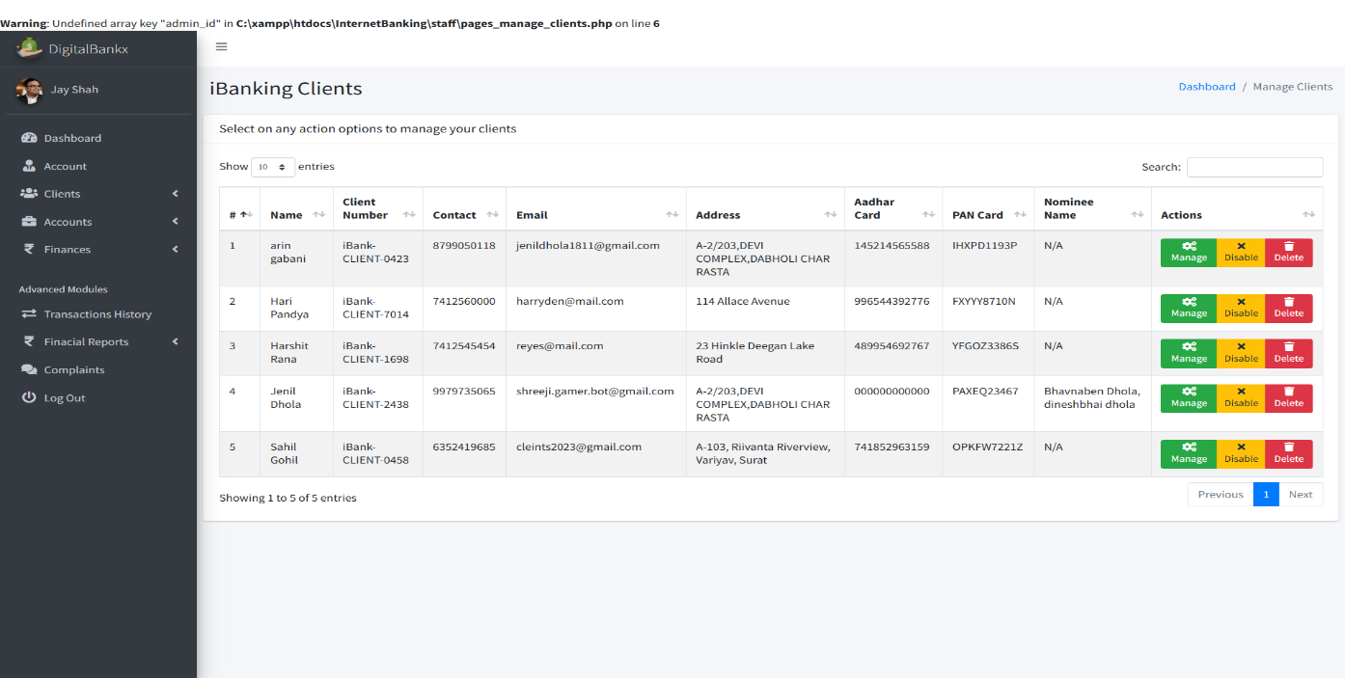

* **In this page use to manage customers who have registered for internet banking.**
* **Account information maintain details like client name, contact, email, address, Aadhaar card, PAN card, etc.**

**Manage client :**

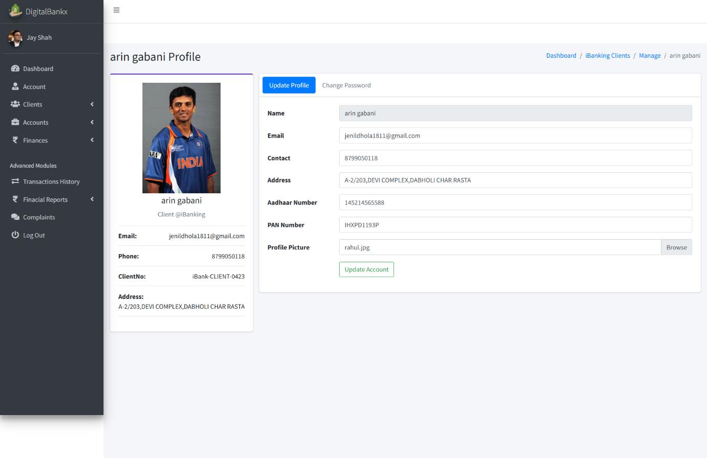

* **In this page use for handing individual customer details.**
* **Change profile pictures and other personal details.**
* **Update details like name, email, phone number, address, Aadhaar number, PAN card, etc.**

**IB account :**

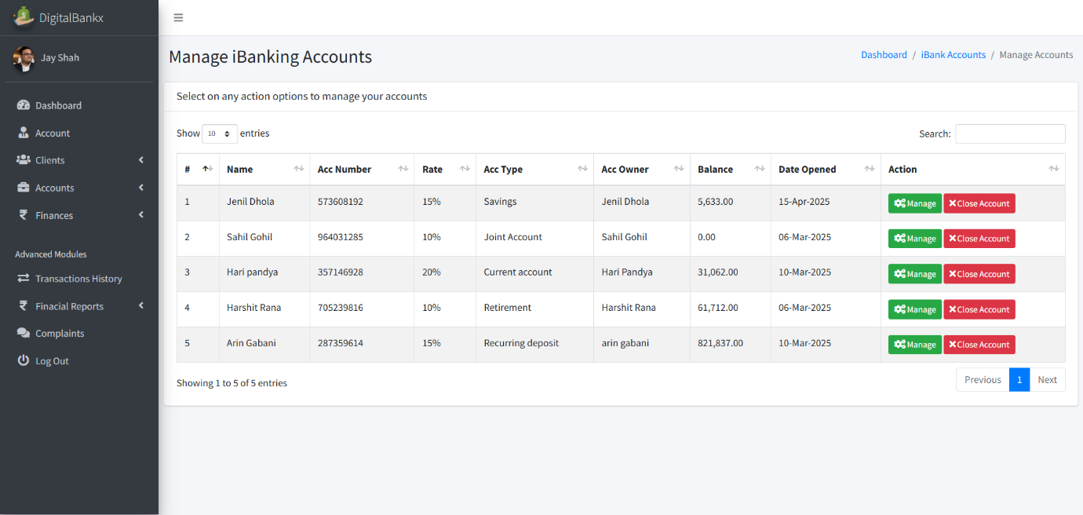

* **In this page used to manage the internet banking accounts of clients.**
* **Handle different types of accounts like savings, current, joint, retirement, and recurring deposit accounts.**

**Manage account:**

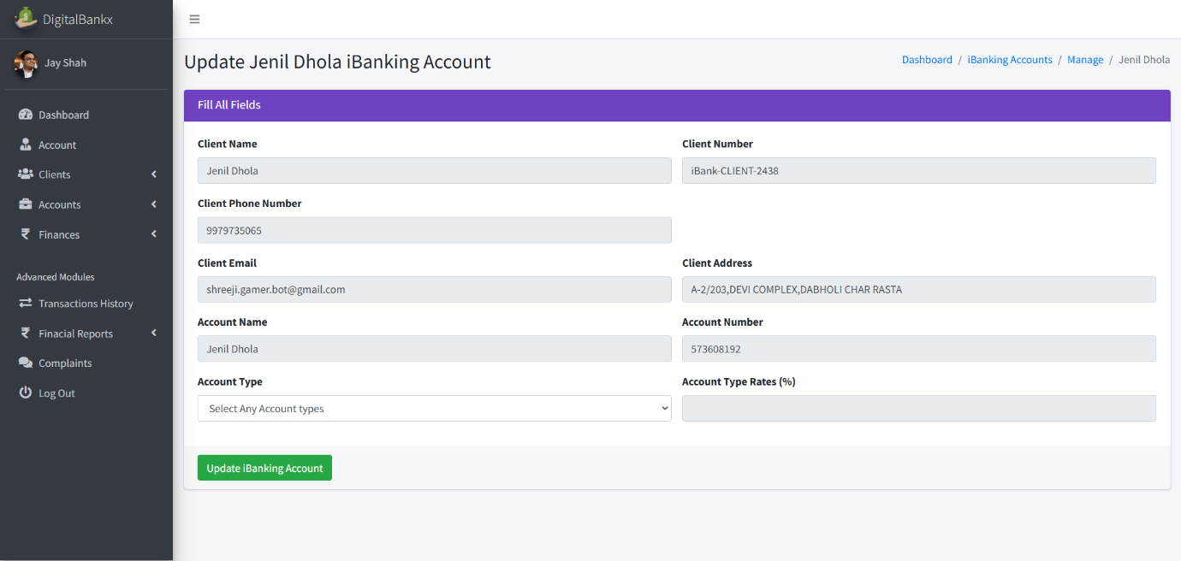

* **In this page used for handling specific internet banking accounts of clients.**
* **Update Client Banking Details to Modify account-related information such as client name, account number, phone number, email, and address.**

**Deposits money:**

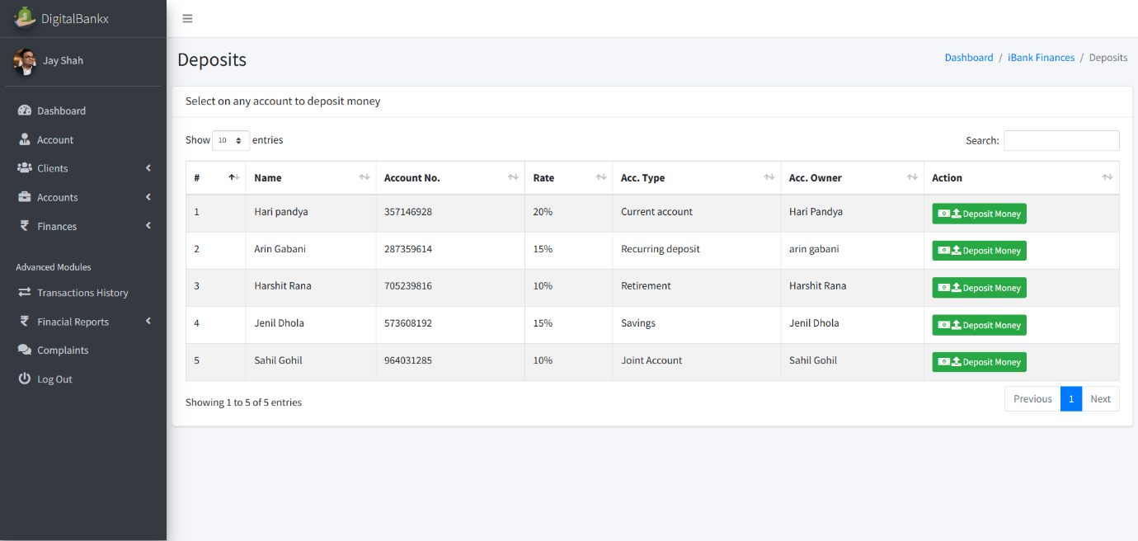

* **In this page use to current account and joint account for deposits money.**
* **Deposits money includes details of multiple accounts money can be deposited.**

**Deposit money:**

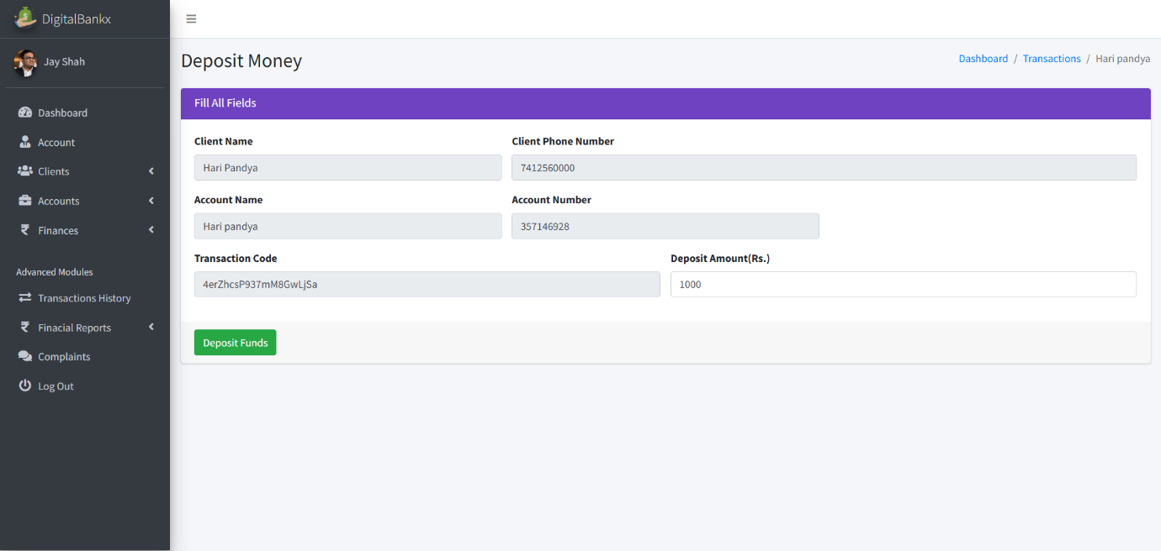

* **In this page deposit is linked to a current account.**

**withdrawals:**

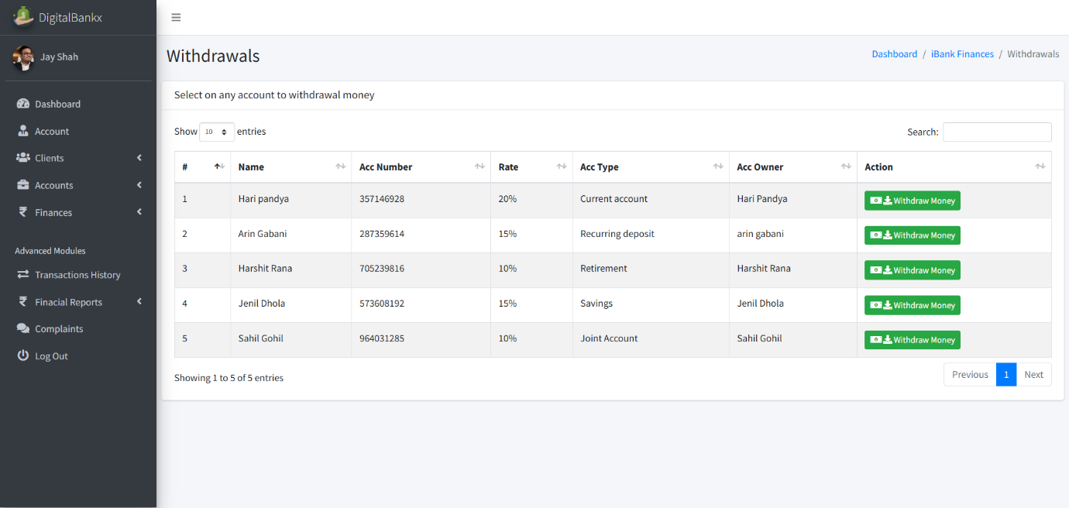

* **In this page withdrawals section allows users to select an account and withdraw funds.**

**Withdraw money:**

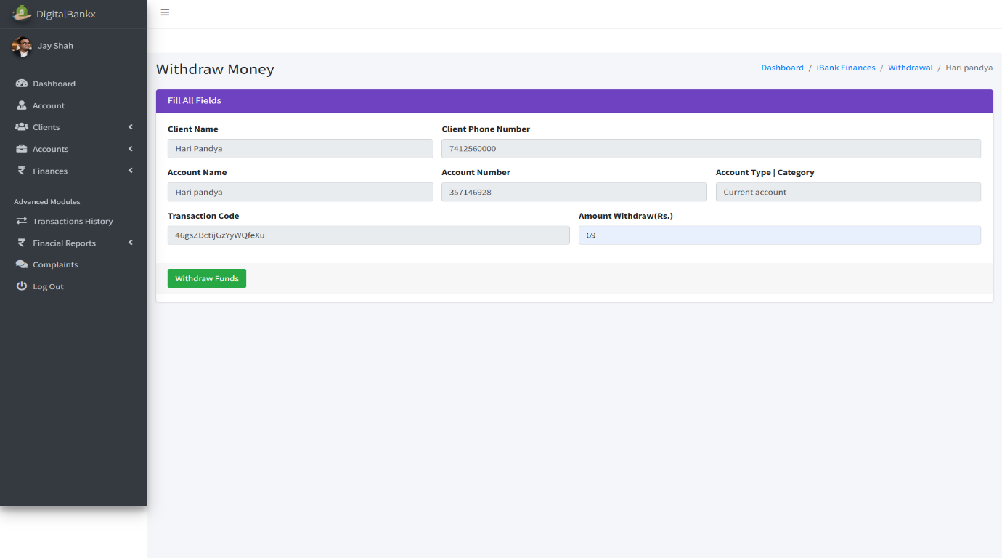

* **In this page allows users to withdraw a specific amount from their account.**
* **transferring it elsewhere or making it available for cash withdrawal.**

**Transfers:**

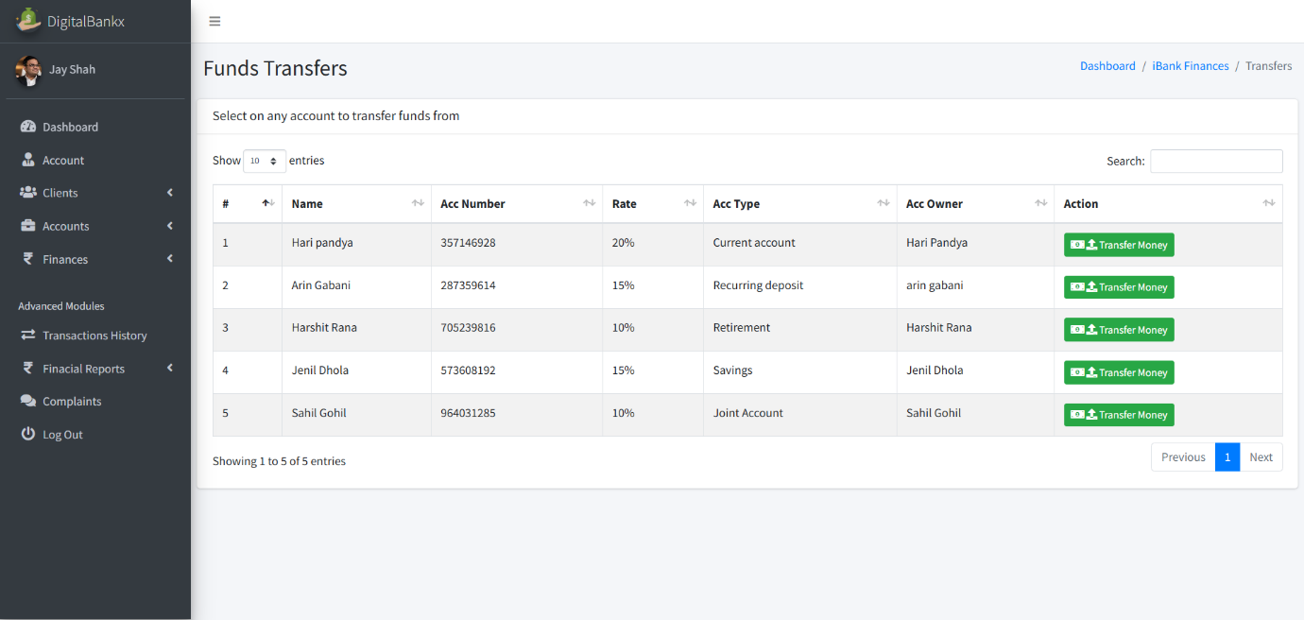

* **in this page Transfer Money section allows users to select an account, enter the recipient’s details, and send funds securely.**
* **Transferring money is used to move funds from one account to another account.**

**Transfer money :**

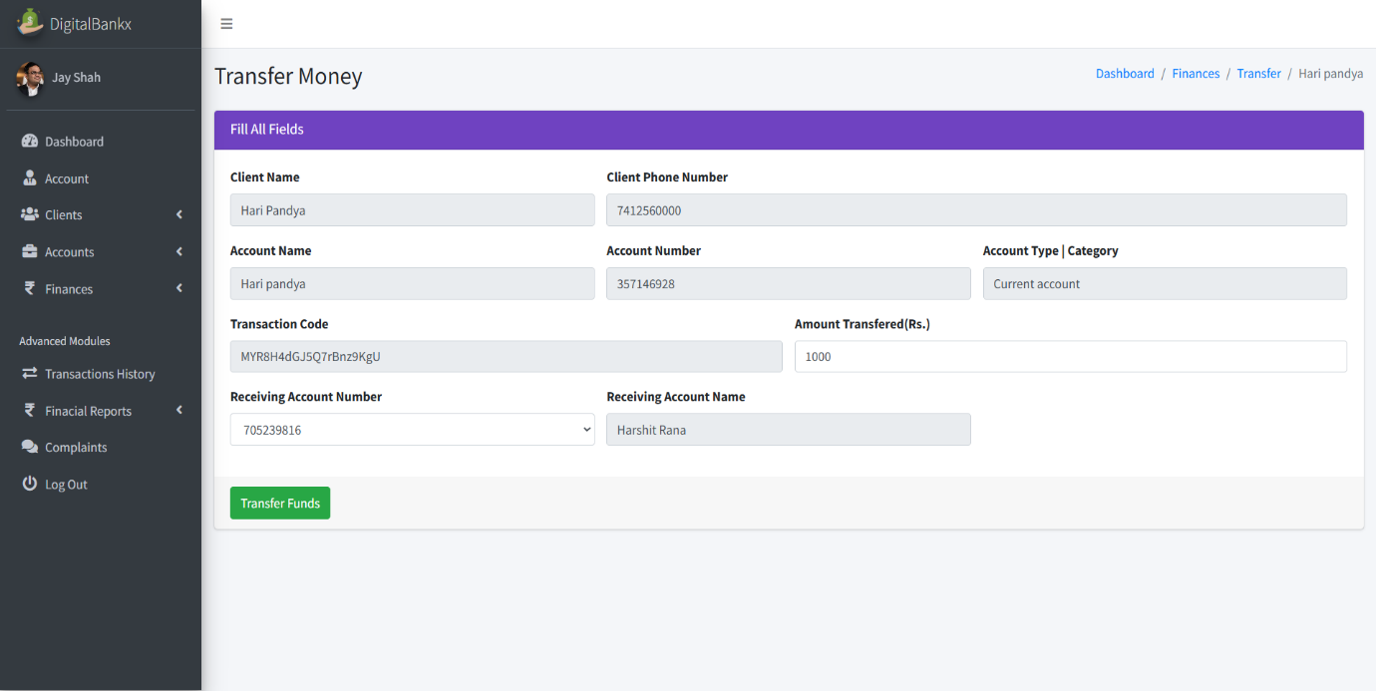

* **In this page use to section is used to move funds from one account to another.**

**Loan application:**

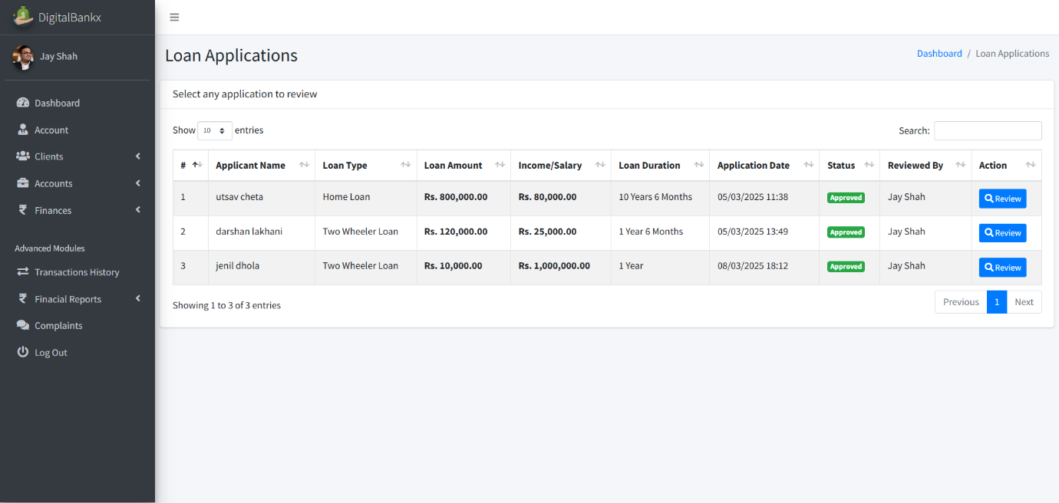

* **In this page used Loan Applications section allows users to submit and review loan requests.**
* **Customers request a loan by providing details like loan type, amount, income, and repayment duration.**

**Review loan application:**

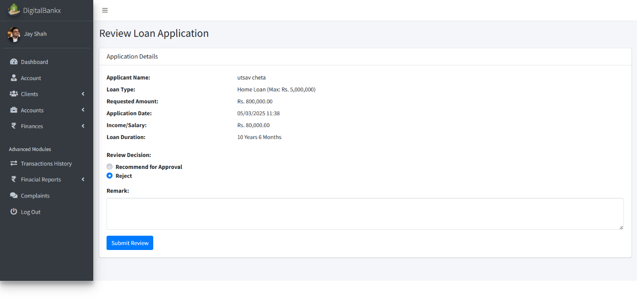

* **In this page use to evaluate and process loan requests.**
* **this feature allows financial institutions or administrators.**

**Balance Inquiries:**

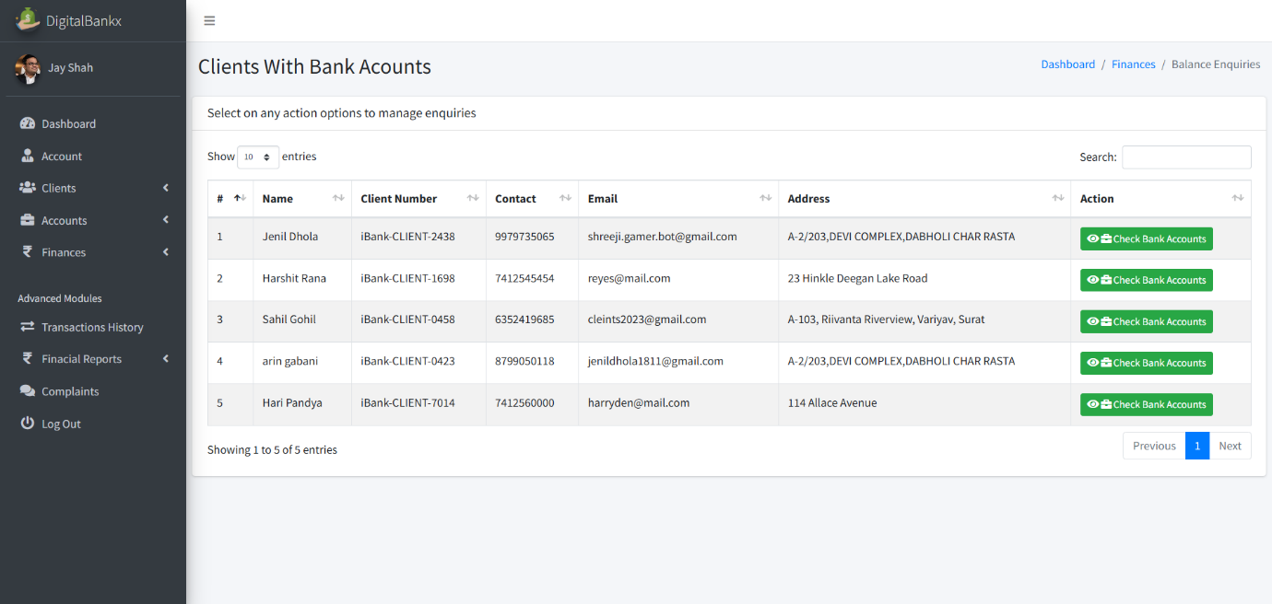

* **in this page use to check and manage the account balances of clients.**

**Check balance :**

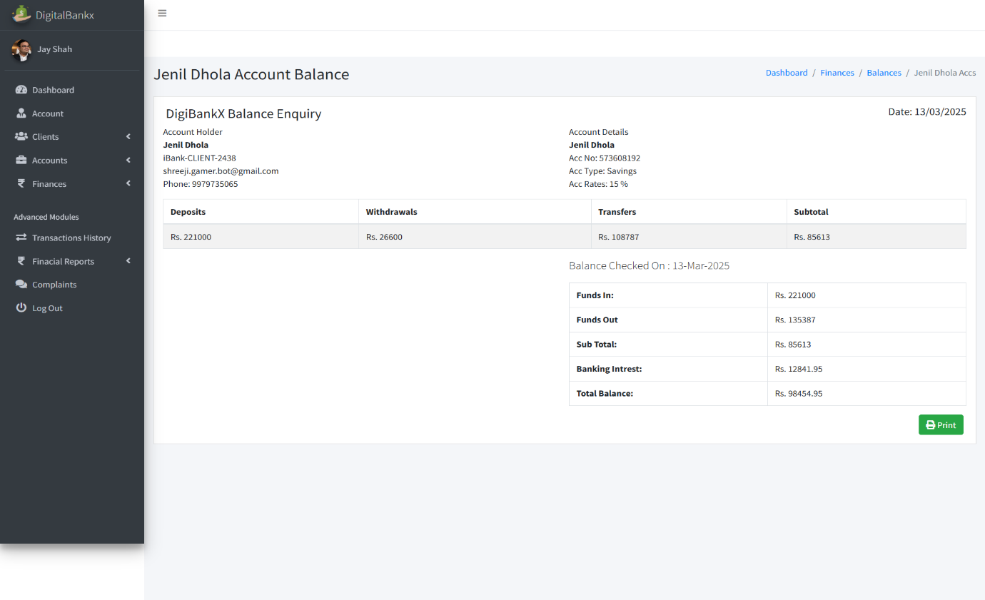

* **Check Balance section is used to view the financial status of a bank account.**
* **Displays the total funds available in the account.**

**Transaction history :**

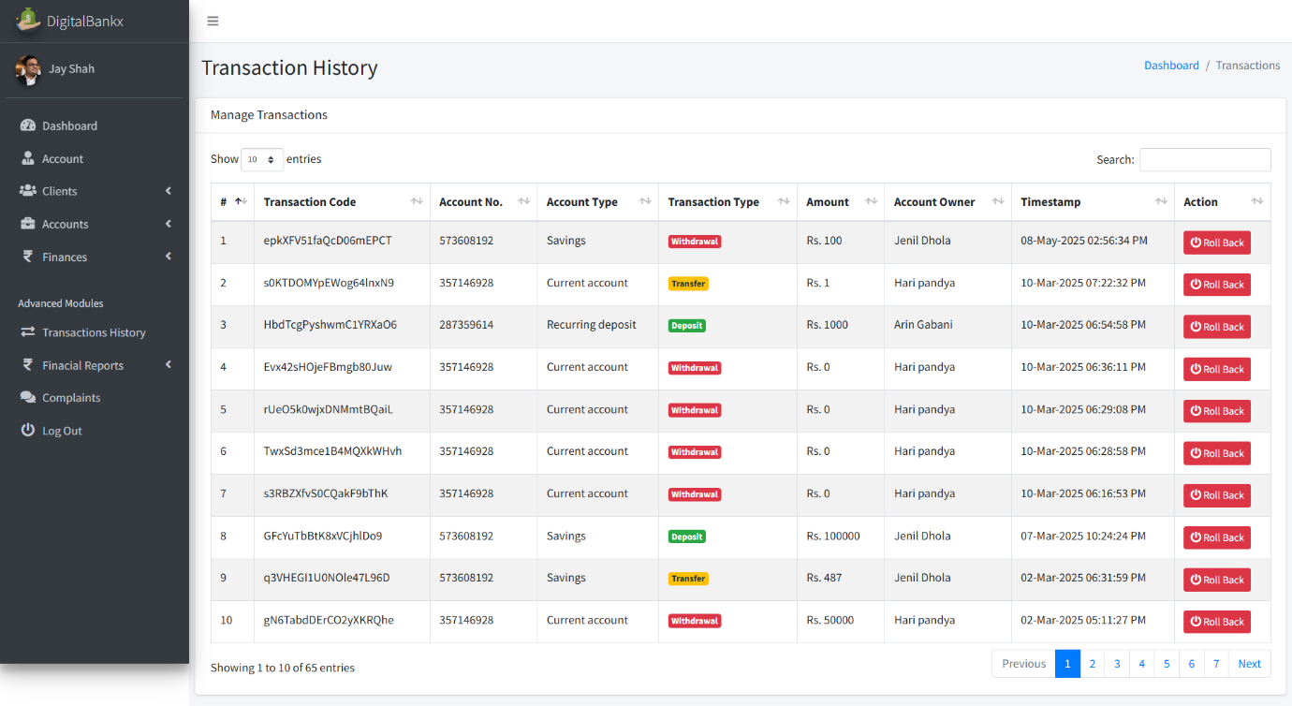

* **In this page Displays deposits, withdrawals, and transfers in one place.**
* **Includes transaction codes, account numbers, amounts, and timestamps.**

**Withdraw history :**

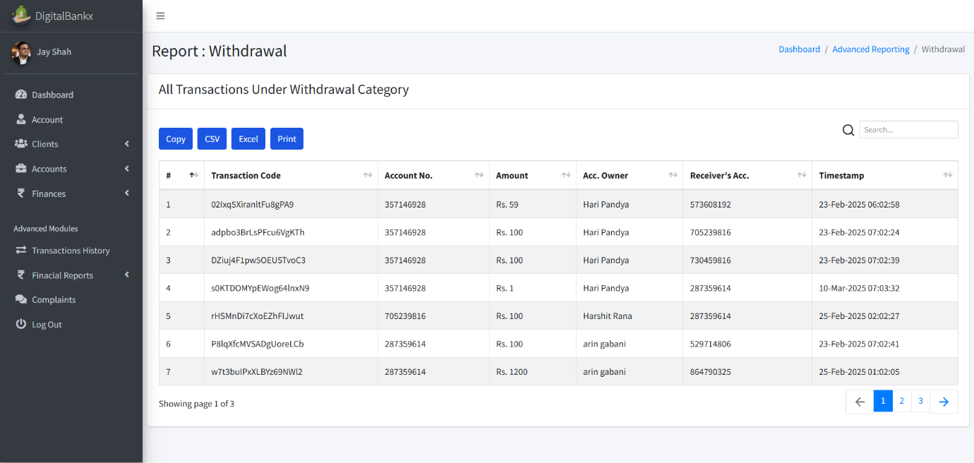

* **In this page used to track and manage all withdrawal transactions made from an account.**
* **Displays all withdrawal transactions, including the amount, account number, and account owner.**

**Deposits history :**

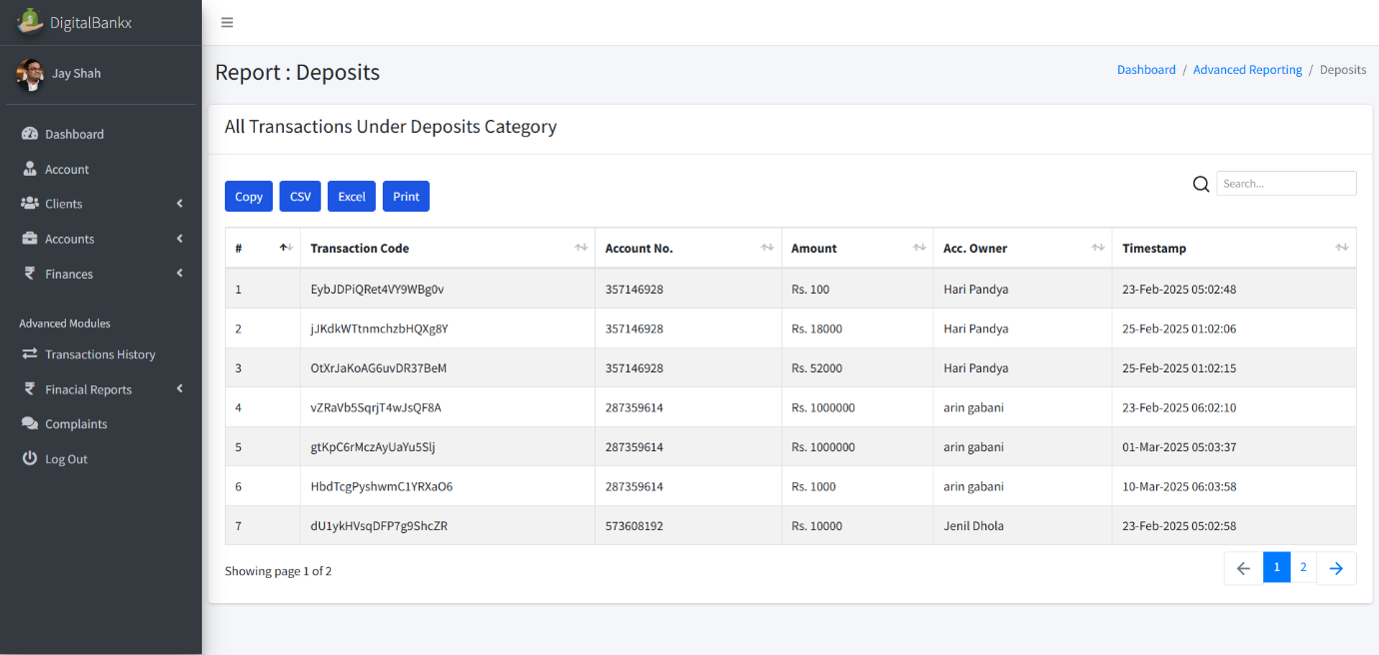

* **In this page used for tracking all deposit transactions made into a bank account.**
* **Allows users to copy, export or print reports for documentation purposes.**

**Transfer history :**



* **In this page used to track all money transfer transactions within a banking system.**
* **Displays details such as transaction codes, account numbers, transferred amounts, and timestamps.**

**Complains:**

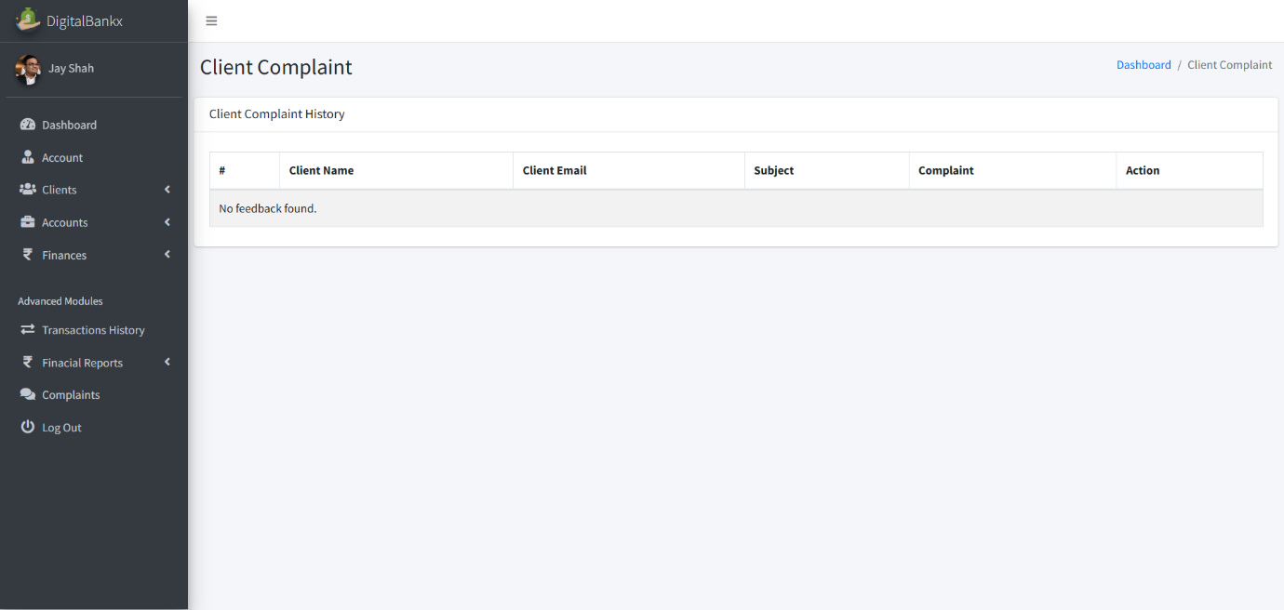

* **Displays customer complaints along with their email, subject, and details of the issue.**
* **Client Side:**

**Visitor page :**

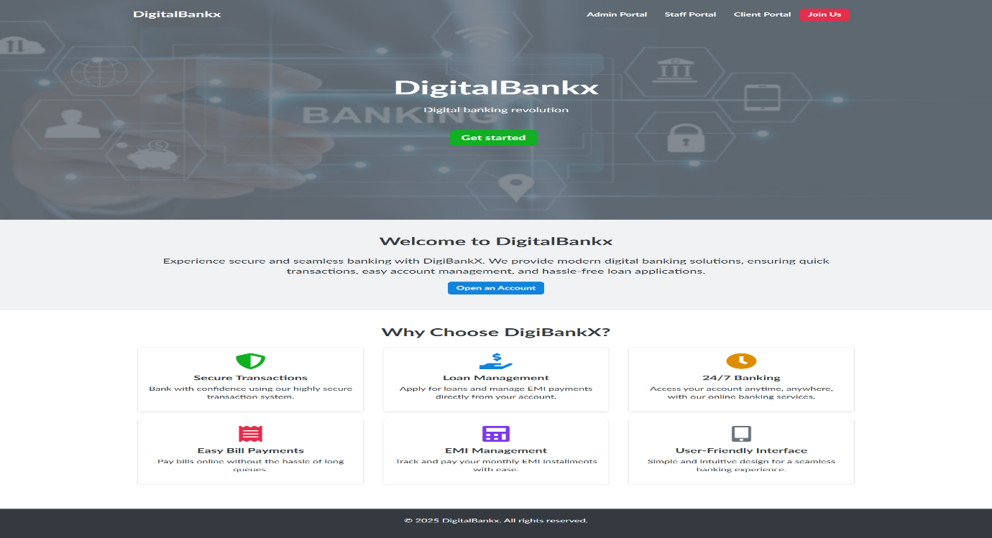

* **Visitor Page in the DigitalBankx platform serves as the landing page for new and potential users.**
* **Includes buttons for Get Started or Open an Account**

**Sign up page:**

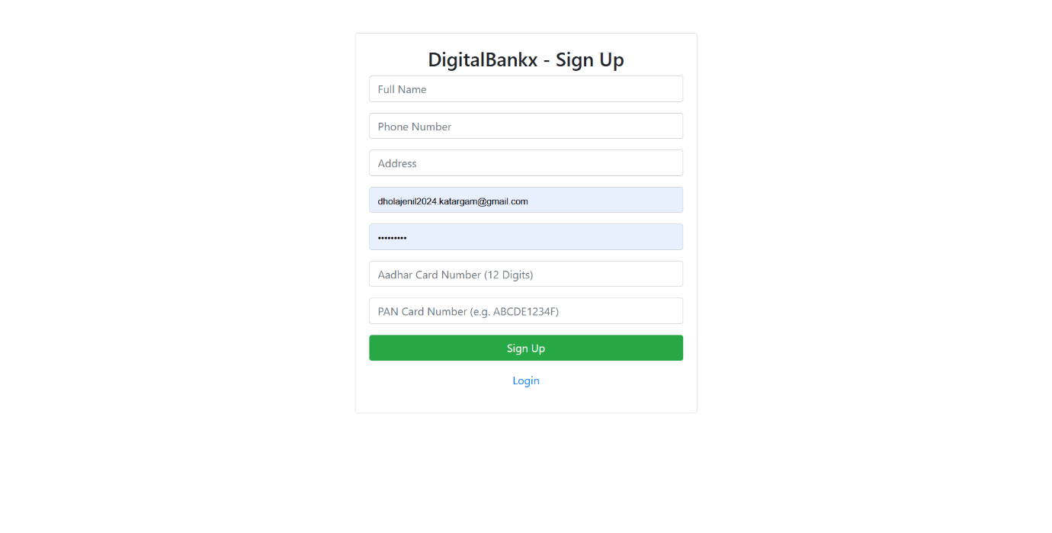

* **In this page used for new user registration, allowing customers to create an account.**
* **Requires users to enter personal details Full Name, Phone Number, Address, Email ID, Aadhar Card Number (12 Digits), PAN Card Number,**

**Password.**

**Log in page**

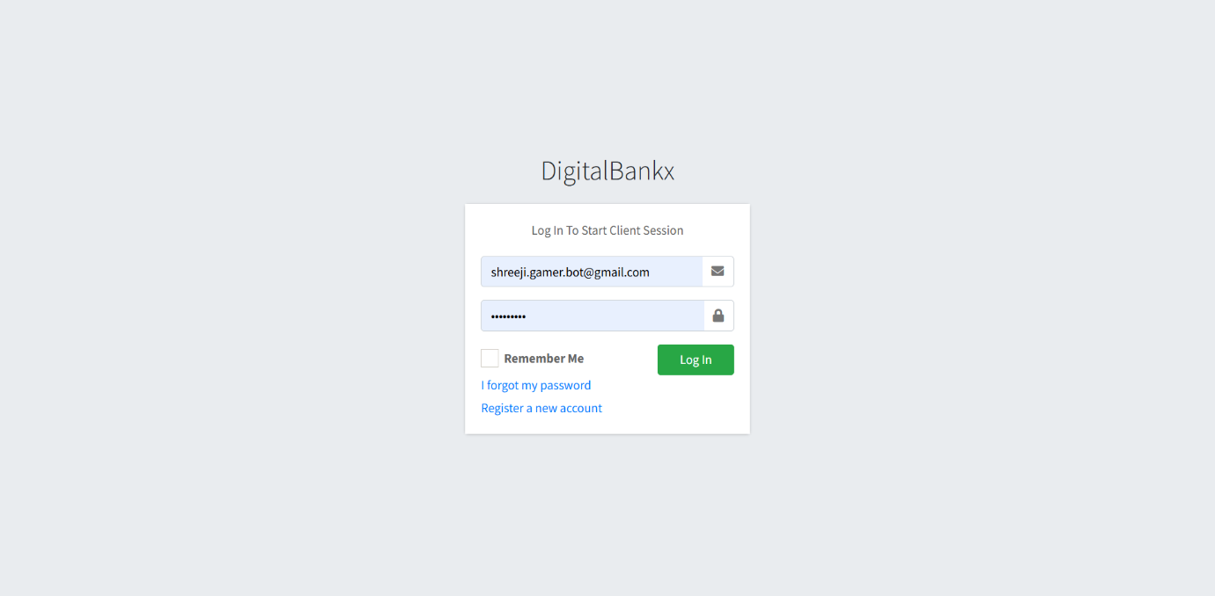

* **In this page used for user authentication, allowing existing customers to securely access their accounts.**
* **Credential Input – Users must enter: Email ID or Username ,Password**

**User dashboard**

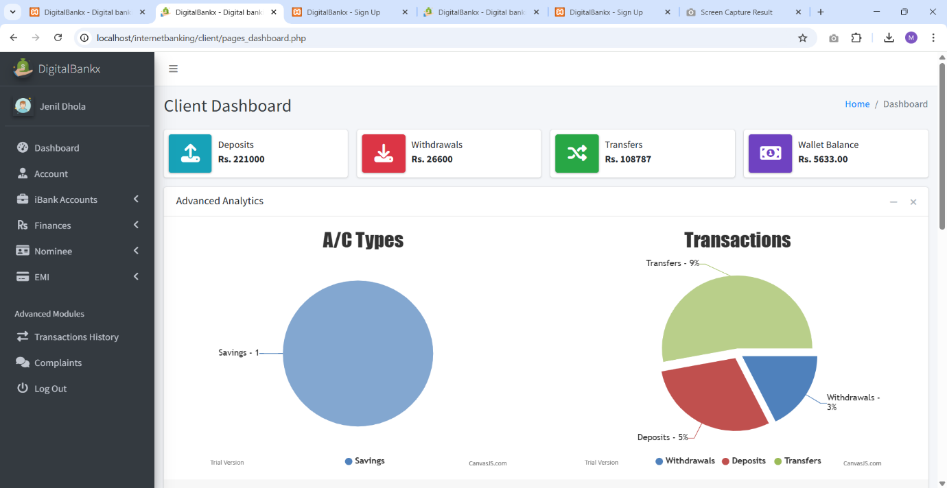

* **In this page Displays deposits, withdrawals, transfers, and wallet balance.**
* **Allows access to features like accounts, finances, transaction history, and complaints.**

**Opening account page :**

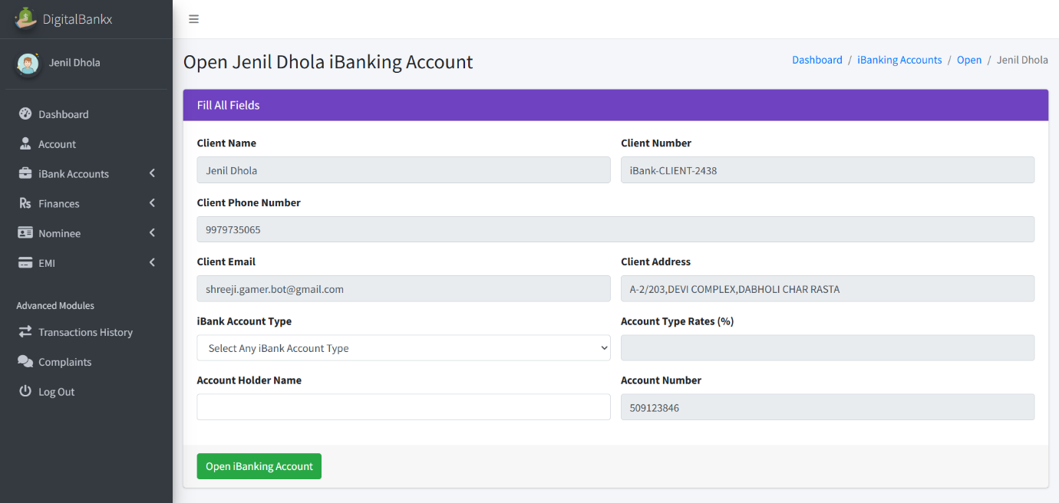

* **In this page allows users to enter their personal details and select an account type.**
* **Display client details, account details, action button.**

**My account page :**

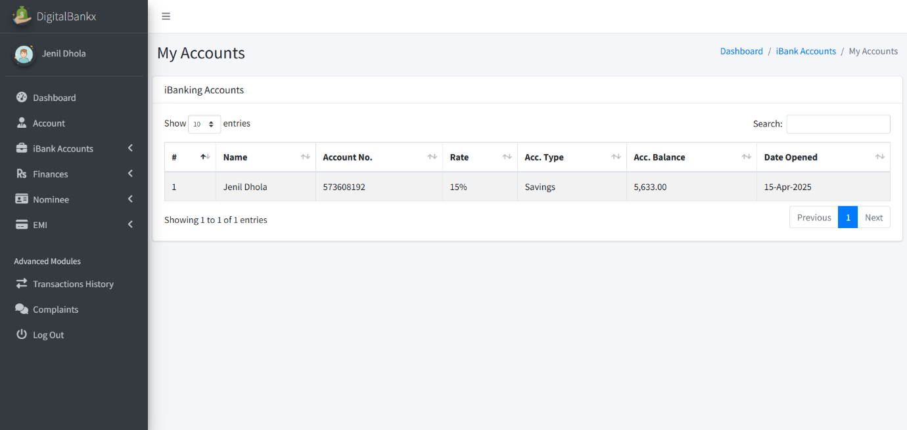

* **This page provides an overview of account-related information.**
* **Display account list table, search and pagination.**

**Deposits:**

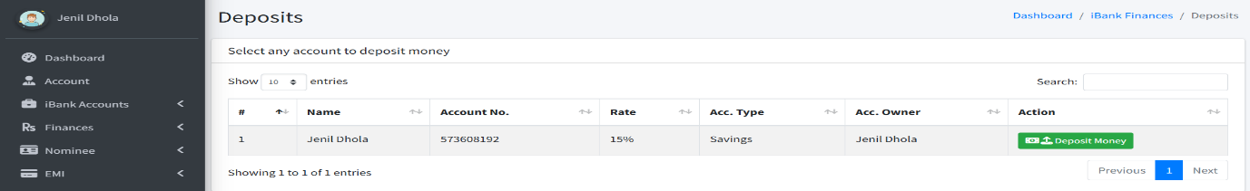

* **Display deposi**

**Transfer deposits**

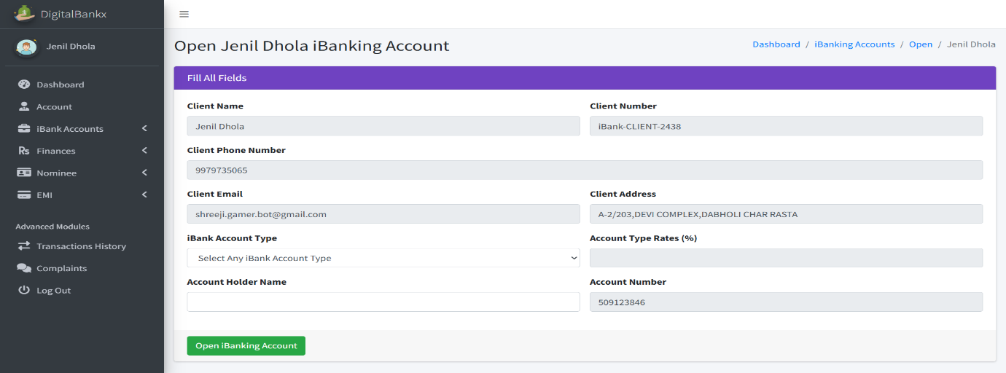

* **In this page use feature that allows users to transfer money into their bank accounts.**
* **There is a green "Open internet Banking Account" button to confirm the deposit transfer.**

**Withdrawals**

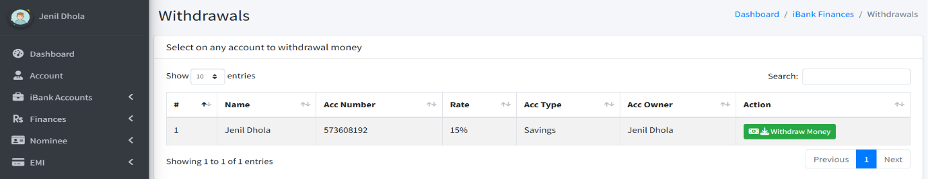

**Withdraw Money**

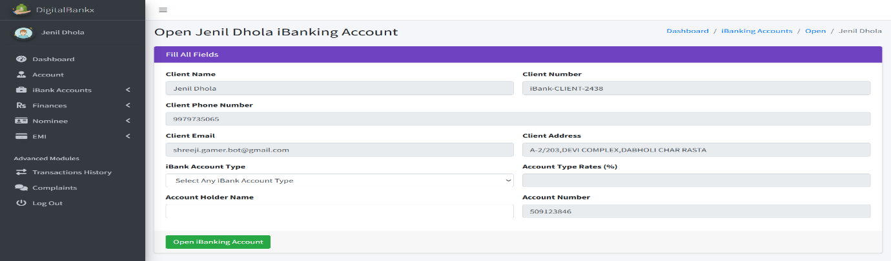

* **In this page allows users to withdraw funds from their bank accounts.**
* **A green "Open internet Banking Account" button is available to confirm the withdrawal.**

**Transfer**

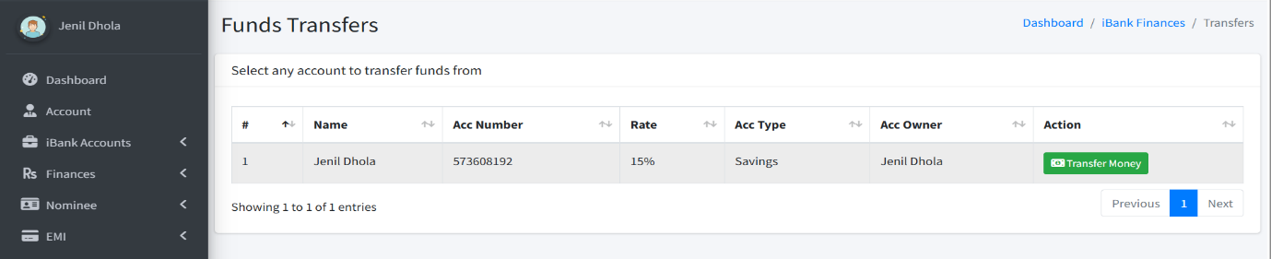

* **In this page allows users to transfer funds between accounts.**
* **A green "Transfer Funds" button is available to finalize the transfer.**

**transfer Money**

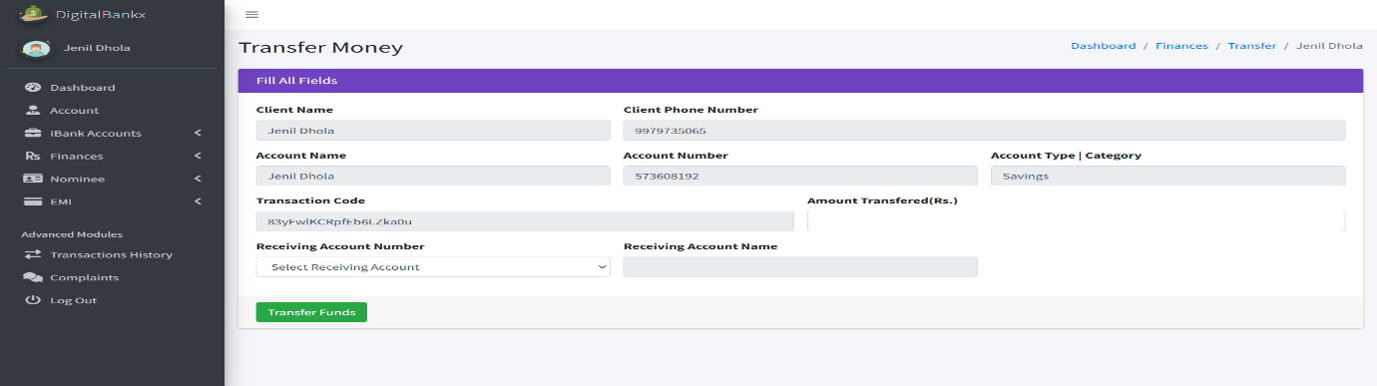

* **Click the green "Transfer Funds" button to process the transaction.**

**Apply for loan:**

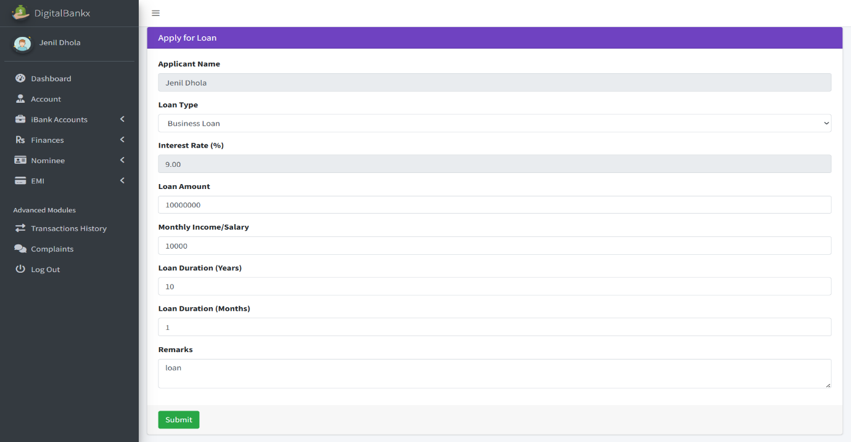

* **The user fills in the required details and submits the loan application.**
* **It enables users to apply for different types of loans: Business Loan,**

**Home Loan, Two-Wheeler Loan, Other types depending on bank options.**

**My loan application**

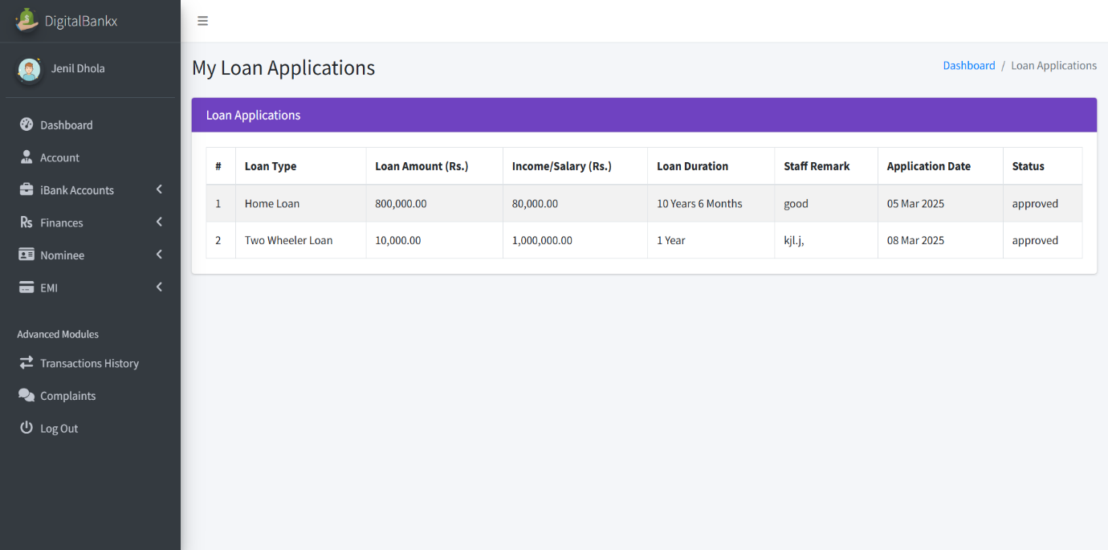

* **Display home loan and two wheeler loan.**
* **Loan application display to loan type, loan amount, income, loan duration, staff remark, application date, status.**

**Balance enquiries :**

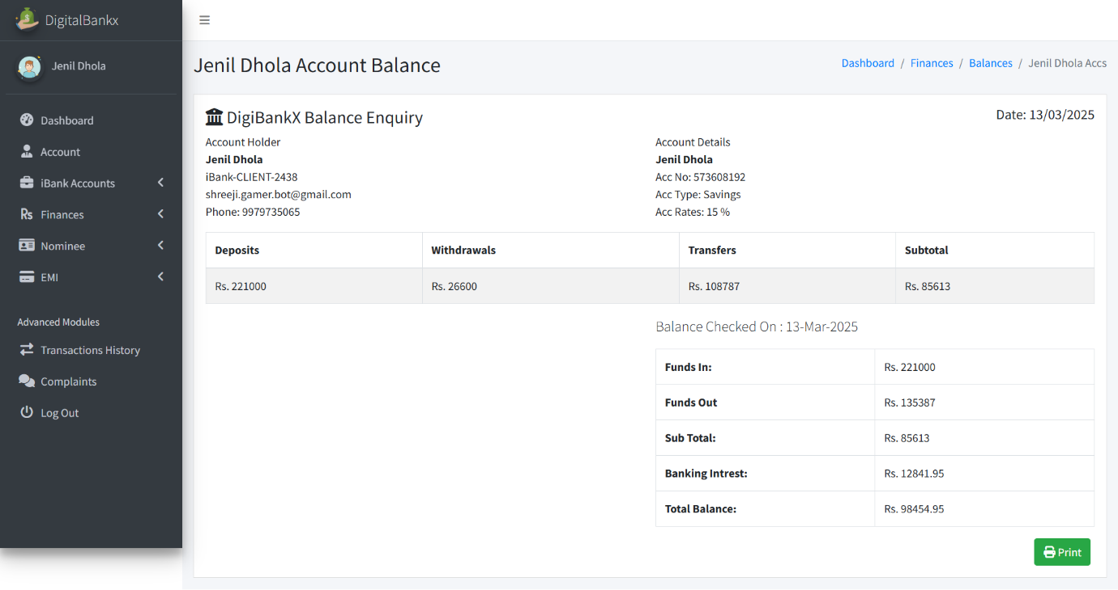

* **In this page shows the account balance details for Jenil Dhola in the DigiBankX system.**
* **It includes:**

**Deposits: ₹2,21,000**

**Withdrawals: ₹26,600**

**Transfers: ₹1,08,787**

**Subtotal: ₹86,613**

**Add nominee:**

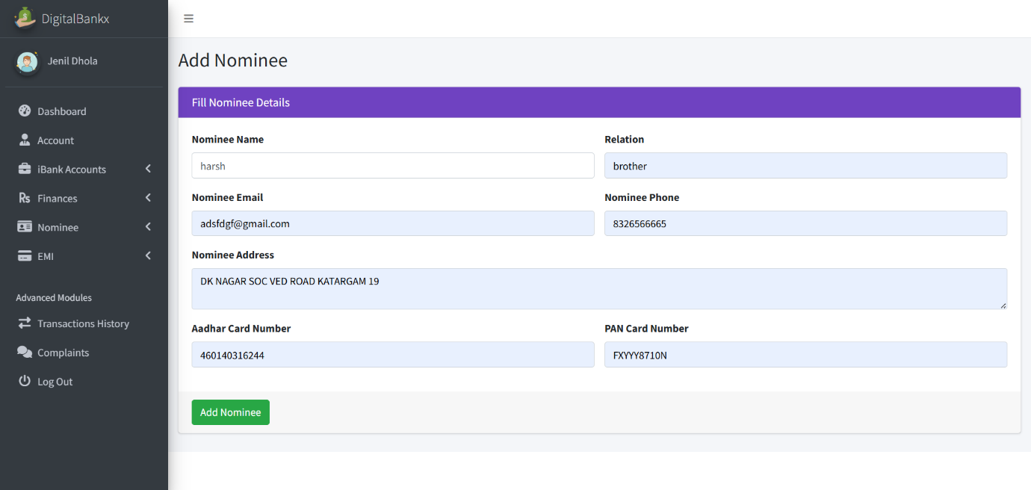

* **In this page Add Nominee" section is used for adding a nominee to a user's bank account.**
* **entering these details, the "Add Nominee" button is clicked to save the information.**

**Transaction history:**

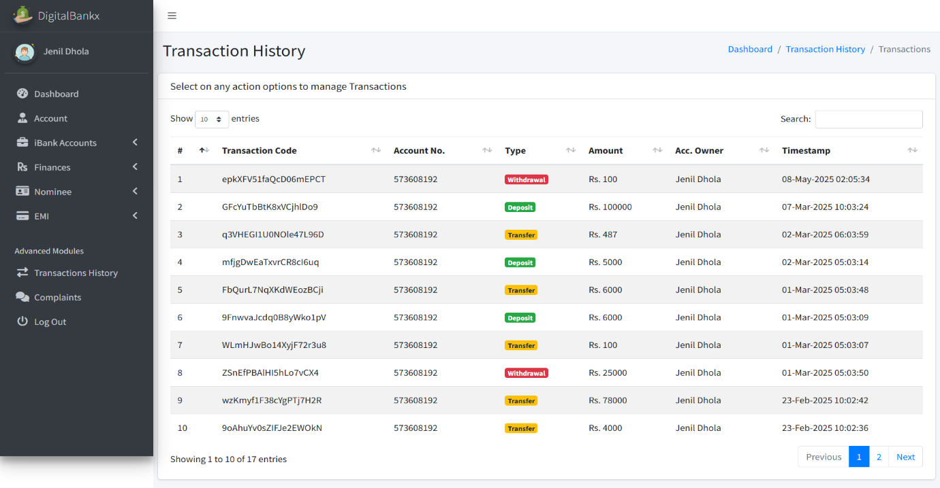

* **in this page Track Financial Activities Users can view all deposits, withdrawals, and transfers in one place.**
* **The history includes color-coded labels for transaction types: Red (Withdrawal), Yellow (Transfer) , Green (Deposit)**

**Complain :**

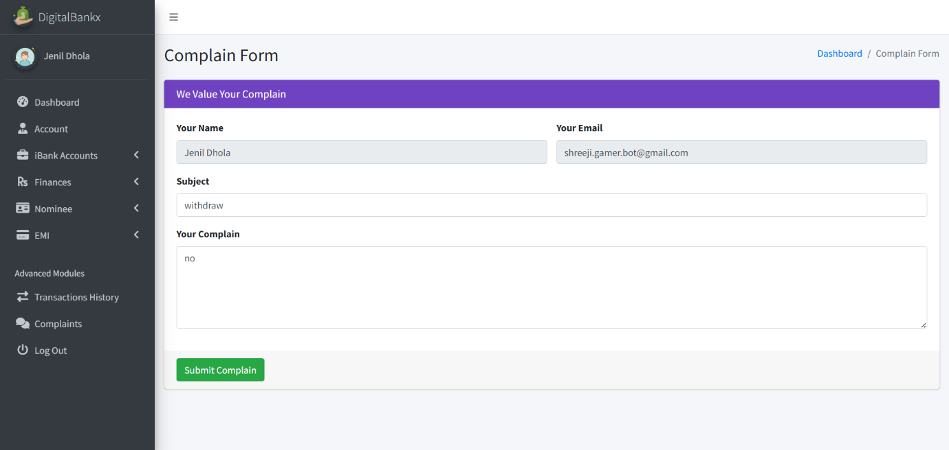

* **feature allows users to report issues related to transactions, account services, or any other banking concerns.**
* **Details in the complaint form: your name, your email, subject, your complaint, submit complaint button.**

**7**

Chapter

**System Limitation and**

**Future Enhancement**

* The project report entitled "**WoodenStreet as Furniture Catalogue**" has finally ended up in its last stage thus achieving almost all its expectations. Based on a truly innovative **“WoodenStreet”** concept, the system website has been developed with much care that it is free of errors and at the same time it is efficient.
* I have tried my level best to make the site as dynamic as possible for updating the website information regularly as and when needed. Also provision is provided for future developments in the system website as per the requirements. Moreover, the entire system website is made secured up to a certain level.
* **Limitations:-**
* Though it is web application but **WoodenStreet** is not in all cities, so limited user will have advantage of site.
* We cannot assign categorizing the customers since at a time only which is set as a default by the admin.
* **Future Enhancement:-**
* We will also include the grading feature.
* In the phase we will integrate the site module to the desktop application, so that the internal work will also be maintained.
* The website can be further upgraded by giving a 3D view of various Products on which the customer can virtually add the accessories esp. the visual parts so as to get an idea of how it looks.

**8**

Chapter

|  |
| --- |
| **References** |

|  |  |
| --- | --- |
| 8.1 | Bibliography |
| 8.2 | Webography |

**8.1 Bibliography**

All the needed information related to my project “**WoodenStreet as Furniture Catalogue”** was being clumped from the following sources:

* **Books:**
* **For PHP**
* PHP Manual
* PHP 5 Fast & Easy Web Development, Julie C. Meloni, 2nd Ed, 2002.

**8.2 Webography**

* **Sites** **URL:-**
* **For PHP**
* www.php.net
* http://www.w3schools.com/php/
* **For MySQL**
* http://dev.mysql.com/doc
* **For JQuery and CSS**
* http://jquery.com/
* http://css-tricks.com/
* http://cssglobe.com/